

**SCHOOL OF** **COMPUTER SCIENCE AND ENGINEERING**

A Project Report

on

Conversion of Handwritten Text into Digitalized Text

Submitted in fulfillment of the requirements for the award of the Degree of

Bachelor of Technology in Artificial Intelligence and Data Science

Submitted by

Anish Kumar (R21EH065)

Under the guidance of

Prof. Kanaiya V Kanzaria

<2024-2025>

Rukmini Knowledge Park, Kattigenahalli, Yelahanka, Bengaluru-560064

www.reva.edu.in

**DECLARATION**

We, Mr. Syed Saaduddin , Mr. Anish Kumar , Mr. Prabhat Rathore and Mr Varun Teja students of Bachelor of Technology, belong in to School of Computer Science and Engineering, REVA University, declare that this Project Report / Dissertation entitled “Conversion of Handwritten Text into Digitalized Text” is the result the of project / dissertation work done by us under the supervision of Prof. Kanaiya V Kanzaria at School of Computer Science and Engineering, REVA University.

We are submitting this Project Report / Dissertation in partial fulfillment of the requirements for the award of the degree of the Bachelor of Engineering in Computer Science and Engineering by the REVA University, Bangalore during the academic year 2024-2025

We declare that this project report has been tested for plagiarism and has passed the plagiarism test with the similarity score of less than 20% and it satisfies the academic requirements in respect of Project work prescribed for the said Degree.

We further declare that this project / dissertation report or any part of it has not been submitted for award of any other Degree / Diploma of this University or any other University/ Institution.

*Signature of the candidates with dates*



*Certified that this project work submitted by Mr. Syed Saaduddin , Mr. Anish Kumar , Mr. Prabhat Rathore and Mr Varun Teja* *has been carried out under Prof Kanaiya V Kanzaria guidance and the declaration made by the candidates is true to the best of my knowledge.*

|  |
| --- |
| *Signature of Guide* |
| *Date: …………….* |

|  |  |
| --- | --- |
| *Signature of HoD* | *Signature of Director* |
| *Date: …………….* | *Date: …………….* |
|  | *Official Seal of the School* |

**SCHOOL OF COMPUTER SCIENCE AND ENGINEERING.**

**CERTIFICATE**

Certified that the project work entitled CONVERSION OF HANDWRITTEN TEXT INTO DIGITALIZED TEXT carried out under my guidance by Mr. Syed Saaduddin [R21EH104], Mr. Anish Kumar [R21EH065], Mr. Prabhat Rathore [R21EH094] and Mr. Varun Teja [R21EH107] ,are bonafide students at REVA University during the academic year 2024-2025, are submitting the project report in partial fulfillment for the award of Bachelor of Technology in Computer Science and Engineering during the academic year 2024-2025. The project report has been tested for plagiarism and passed the plagiarism test with a similarity score less than 20%. The project report has been approved as it satisfies the academic requirements in respect of Project work prescribed for the said Degree.

|  |  |
| --- | --- |
| **Signature with date** |  |
|  |  |
| **Prof. Kanaiya V Kanzaria** |  |
| **Guide** |  |

|  |  |
| --- | --- |
| **Signature with date** |  |
|  |  |
| **Prof. Kiran M** | **<**  **Dr. Ashwinkumar U M** |
| **HoD** | **Director** |

**External Examiners**

**Name of the Examiner with affiliation Signature with Date**

**1.**

**2.**

**ACKNOWLEDGEMENT**

Any given task achieved is never the result of the efforts of a single individual. There are always a bunch of people who play an instrumental role leading a task to its completion. Our joy at having successfully finished our mini project work would be incomplete without thanking everyone who helped us out along the way. We would like to express our sense of gratitude to our REVA University for providing us the means of attaining our most cherished goal.

We would like to thank our Hon’ble Chancellor, Dr. P. Shyama Raju and Hon’ble Vice-Chancellor, Dr Sanjay R. Chitnis for their immense support towards students to showcase innovative ideas.

We cannot express enough thanks to our respected Director, Dr Ashwini Kumar U M for providing us with a highly conducive environment and encouraging the growth and creativity of each and every student. We would also like to offer our sincere gratitude to our Project Coordinators for the numerous learning opportunities that have been provided.

We extend our heartfelt gratitude to our Head of the Department, Prof. Kiran M for their unwavering support, encouragement, and vision that guided us throughout the course of our project. Their leadership has been an invaluable source of motivation for all of us, and we truly appreciate the knowledge and guidance they have provided.

We would like to take this opportunity to express our gratitude to our Project Guide Prof. Kanaiya V Kanzaria, for continuously supporting and guiding us in our every endeavor as well as for taking a keen and active interest in the progress of every phase of our Project. Thank you for providing us with the necessary inputs and suggestions for advancing with our Project work. We deeply appreciate the wise guidance that sir has provided.

Finally, we would like to extend our sincere thanks to all the faculty members and staff from the School of Computer Science and Engineering.

**Contents**

|  |  |
| --- | --- |
| List of tables with titles and page references | 28-32 |
| List of illustrations / Screen Shots if any, with titles and page references | 102-111 |
| Abstract | 6-7 |
| 1. Introduction | 8-10 |
| 1. Literature Survey | 11-30 |
| 1. Positioning | 31-35 |
| * 1. Problem statement | 31-32 |
| * 1. Product position statement | 33-35 |
| 1. Project overview | 36-39 |
| * 1. Objectives | 38 |
| * 1. Goals | 39 |
| 1. Project Scope | 40 |
| 1. Methodology | 41-53 |
| 1. Modules identified | 53-58 |
| 1. Project Implementation | 59-94 |
| * 1. Architectural Design, Circuit Design (Hardware Project) and Mechanical and Control Unit Design (Robotics or automation projects) | 72-77 |
| * 1. Class Diagram | 77-83 |
| * 1. Entity Relationship Model | 83-87 |
| * 1. Sequence Diagram | 88-90 |
| * 1. Description of Technology Used | 90-94 |
| 1. Findings / Results of Analysis | 95-96 |
| 1. Cost of the Project | 98 |
| 1. Conclusions | 99 |
| 1. Project Limitations and Future Enhancements | 100-101 |
| References | 101-102 |
| Copies of Articles: | 103-105 |
| Conference papers published (Certificate with Published Paper) | 103 |
| Plagiarism Report………………………………………………………………………. | 104 |
| Any Awards achieved (Certificates) | 105 |

**Abstract:**

Handwritten text recognition (HTR) is still a challenging problem in the field of pattern recognition because of the diversity of individual writing styles, shapes, and languages. It has great practical applications in the real world, ranging from digitizing historical records and legal documents to improving postal sorting machines and form automation. With time, the attention of HTR methods has shifted from traditional machine learning approaches to sophisticated deep learning architectures, which provide better flexibility and accuracy. This abstract provides a general description of the developing scene of handwritten text recognition, with a focus on the key elements characterizing contemporary recognition systems.

An important step in improving recognition accuracy starts with good pre-processing methods. These encompass noise removal, normalization, binarization, and skew correction to normalize input images for proper interpretation. Pre-processing is followed by feature extraction to extract meaningful patterns and structural features from handwritten inputs. Handcrafted features have progressively been overtaken by deep learning-based features with Convolutional Neural Networks (CNNs), Recurrent Neural Networks (RNNs), and hybrid networks that learn representations automatically from data.

In recent advancements, model optimization and design have experienced significant advancements with architectures such as Long Short-Term Memory (LSTM) networks and Transformer-based models that can model long-range dependencies within text sequences. End-to-end models, commonly using Connectionist Temporal Classification (CTC) loss or attention, have been very effective in processing unsegmented handwritten text. In addition, generative models and encoder-decoder architectures are becoming increasingly popular for their versatility in generating output sequences.

This review also contrasts the performance of these systems on benchmarking datasets like IAM, RIMES, and NIST, providing clues about their accuracy, robustness, and generalization. It shows how different models fare under different situations like cursive vs. printed text, or single-language vs. multi-script inputs. Besides, activities are divided between offline and online recognition, where the latter handles static scanned images and the former handles stroke-by-stroke input from devices such as tablets and styluses.

Even after major improvements, many challenges remain in this area. They are handling very cursive scripts, touching characters, variable baselines, and multilingual data. Additionally, adjusting systems to low-resource languages and historical scripts is an open issue. The work also touches on future perspectives, such as combining self-supervised learning, data augmentation, and federated learning for privacy-preserving handwriting recognition.

In summary, this abstract summarizes contemporary innovations and longstanding challenges encountered during handwritten text recognition. It shall act as a roadmap for practitioners and researchers attempting to create better and more effective HTR systems. Through identifying major areas such as pre-processing, feature extraction, model training, and assessment, the subject continues to head towards the establishment of robust solutions that can tolerate real-world handwriting variability.

**Keywords: -**

Handwritten Text Recognition, pattern recognition, deep learning, machine learning, recognition accuracy, pre-processing, feature extraction, model design, optimization, evaluation, benchmark datasets, Convolutional Neural Networks (CNNs), Recurrent Neural Networks (RNNs), Long Short-Term Memory (LSTM), Transformer-based models, encoder-decoder architecture, Connectionist Temporal Classification (CTC), attention mechanism, end-to-end models, generative models, IAM dataset, RIMES dataset, NIST dataset, offline recognition, online recognition, cursive text, printed text, mixed script, multilingual datasets, low-resource languages, historical scripts, writing style variability, overlapping characters, baseline inconsistency, real-world variability, self-supervised learning, data augmentation, federated learning, privacy-preserving models.

**Chapter 1: Introduction:**

In the advent of the digital age, the necessity of closing the gap between handwritten content of the old era and contemporary digital media is more important than ever before. While handwritten papers still constitute a popular means of note-taking, form completion, and information recording in everyday life, they are faced with great challenges when it comes to long-term preservation, effective retrieval, revisions, and dissemination. Their lack of digitization restricts their usability and accessibility in the current information-oriented setup. Translating written content to editable, searchable digital forms represents a promising answer that enhances usability as well as accessibility, making it possible for people and institutions to better handle information.

Digitization of hand-written text is the process of converting analog input—like hand writing on paper or tablet input with a stylus—into editable and machine-readable forms. Document management is improved as it is easy to archive, edit, and analyze. It further allows wider applications such as helping blind people, automating manual data entry, and keeping up with future generations' historical manuscripts.

This article is concerned with the creation and improvement of systems that translate handwritten input into digital text. The fundamental technologies driving this process involve a blend of image processing methodologies and machine learning algorithms, especially those applied in Optical Character Recognition (OCR). OCR stands for automated identification and text extraction from images, and when it is coupled with sophisticated artificial intelligence (AI) methods, it is able to deal with tough and varied handwriting styles with amazing accuracy.

The main goal of this research is to develop a robust and effective system capable of reading and digitizing handwritten text with high accuracy, even when confronted with typical challenges like inconsistent handwriting, background noise, and different input formats. Since handwriting varies significantly among individuals and can be influenced by factors such as writing instruments, paper quality, and speed of writing, the practical recognition system must be versatile and resilient. This paper provides a step towards that by outlining existing methodologies, determining challenges, and suggesting practicable solutions in order to advance handwritten text recognition systems.

Handwritten text recognition usually entails multiple steps. Pre-processing is the first step, which is an important step in which the input image is cleaned and made ready for analysis. This includes processes such as binarization, which reduces the image to black and white, skew correction to straighten tilted text, and noise removal to remove unwanted artifacts. These normalize the input and make the next stages more efficient.

After pre-processing, the text is segmented to break it down into units of lines, words, or characters. Proper segmentation is necessary for the proper identification of single characters, particularly where the handwriting is cursive or overlapping. Inaccurate segmentation may cause wrong character recognition and hence this step is very crucial.

The second phase, feature extraction, entails the detection of characteristic visual features of the text, including strokes, curves, and contours. The first is used to distinguish different characters and is crucial for training recognition systems. Handcrafted features were employed in traditional techniques, whereas deep learning methods are preferred in recent developments, where features are learned directly from the data, improving efficiency and accuracy.

After features have been extracted, the recognition stage projects these visual features onto familiar character classes through classification algorithms. This is where machine learning comes into play. Advanced recognition systems tend to utilize neural network models such as Convolutional Neural Networks (CNNs) for spatial processing and Recurrent Neural Networks (RNNs) for sequential data handling, particularly in the case of connected handwriting. Such networks learn on massive collections of data so as to precisely distinguish characters regardless of the style of writing, alignment, or distortion.

Post-processing is the last step in the OCR pipeline, where raw output is cleaned up. It involves correcting spelling errors, enforcing grammatical rules, and employing language models to make the text coherent and contextually relevant. This process enhances the quality of the recognized text as a whole and makes it suitable for real-world applications in digital systems.

Recent advancements in AI have greatly enhanced the power of OCR systems. Old OCR engines were usually rule-based and inflexible, but current AI-driven systems are flexible and can learn from user corrections. Deep learning algorithms can handle noisy images, identify unusual handwriting, and even learn new characters with little retraining. This flexibility has opened the use of OCR to more sophisticated use beyond traditional purposes to recognizing text on signboards, examining handwritten historical archives, and even detecting and digitizing mobile camera input text.

AI-based OCR technology has also created new applications, such as intelligent document recognition for business automation, plate recognition in intelligent traffic systems, and digitization of handwritten lecture notes for academic purposes. Moreover, coupling OCR with mobile and cloud environments has made text recognition in real time while on the move a reality, available to many more.

Even with these developments, a number of challenges still stand in the way of universal adoption of OCR for handwritten text. Varied handwriting styles, language variations, intricate layouts, and low-quality scans still affect accuracy. In addition, OCR systems need to be made in a way that they will honor user privacy and function well in multilingual and low-resource settings. These challenges highlight the importance of ongoing research and innovation.

Finally, translating handwritten material to digital content is now at the forefront of data management and availability today. Through the convergence of OCR, AI, and deep learning, we are now capable of constructing highly capable systems to interpret even complex handwritten data. This work surveys the end-to-end handwritten text recognition pipeline, from acquiring the images through the output as text, and how every component of it can be tuned to be more effective. With this study, we hope to provide valuable insights and actionable approaches for pushing the frontiers of handwriting digitization technologies in a fast-changing digital world.

**Chapter 2 : Literature Survey:**

**1. Hao, W. (2024). Deep learning-based image text recognition technique in digital auditing research. In Proc. 2024 Int. Conf. Comput. Multimedia Technol., pp. 100–104.**

**Summary of the Source:**

In this paper, Hao (2024) investigates the application of deep learning to improve text recognition from images, and in this case, in the context of digital auditing. The author tackles the growing need for automated processes in processing huge amounts of printed and handwritten documents, particularly in audit and compliance settings where financial document data extraction is critical. The article introduces a new image-to-text system using convolutional neural networks (CNNs) to extract features from input images and transform them into text sequences.

The method starts with image pre-processing, which involves noise removal and binarization for improved image quality. The system thereafter uses the CNN layers for extracting features and then recurrent neural networks (RNNs) or long short-term memory (LSTM) units to address sequentiality in text. The incorporation of deep learning allows the system to identify intricate handwriting styles and deal with variations in character shapes, slants, and alignments, which are typical in real-world document datasets. The performance of the system is tested using a dataset of scanned financial documents and audit forms and is found to be highly accurate in both numeric and alphabetic text recognition.

**Synthesis with Prior Work:**

Hao's method extends and greatly enhances prior OCR-based techniques that were dependent on template matching or light-weight machine learning classifiers. Previous OCR software tended to perform poorly against noisy images and demanded rigorous formatting of documents, which restricted its flexibility. Compared to these traditional methods, Hao's model incorporates an end-to-end deep learning architecture, where the need for human feature engineering is minimized, and recognition capabilities are enhanced regardless of the differences in handwriting patterns.

In comparison to previous work that targeted only printed text or generic datasets such as MNIST, this research uses its model on a niche domain—financial auditing—and hence provides new domain-specific observations. The move towards deep neural networks for image-based text reading is an extension of wider progress in the area and highlights the waning usefulness of manual OCR pipelines in contemporary applications.

**Relevance to Problem Statement:**

The relevance of the study to our project's central issue—automating handwritten text digitization—is immediate and substantial. Our aim to create a system that translates handwritten notes, forms, and documents into editable digital text is aligned with Hao's goals, particularly in enhancing accuracy and efficiency using AI. His model shows the viability of applying deep learning to highly accurate recognition tasks and offers valuable architectural guidelines for implementation.

This is especially valuable in our context, as variation in handwriting, noise, and document quality constitute significant hurdles. Hao's approach offers a solution that not only addresses these issues but does so in a form that is capable of scaling up to big datasets without needing human tuning, thereby making it a very suitable building block for our suggested system.

**Product Positioning Fit :**

Although Hao's system is designed particularly for auditing procedures in institutional or corporate settings, the model used is generic enough to be modified for wider usage. As an instance, our product for education, administrative, and archival spaces can be made use of with a reduced variant of Hao's model. Our version may sidestep the higher computational overhead by performing optimizations on the network structure or employing light models such as MobileNet in mobile or low-resource environments.

In addition, Hao's work highlights the need to integrate text recognition within current digital processes. This fits with our approach of building an end-to-end pipeline that not only captures text but also supports editing, sharing, and storing within a single digital environment. His research provides the foundation for investigating analogous real-time applications with an intuitive user interface.

**Critical Evaluation:**

As strong as the paper is, it also has limitations that need to be noted. One significant issue is that it relies heavily on powerful hardware for training models and inference, which might not be possible with small organizations or personal devices. Another issue is that the used dataset, although extensive, is domain-dependent and will likely have poor generalizability to other handwriting or document formats. There is not much mention of post-processing methods like grammar correction or context-dependent word prediction, which are essential for actual usability.

However, Hao's contribution is invaluable, providing an high-performance model that is particularly effective in the structured domain such as auditing. The paper has a clear pathway to applying deep learning to text recognition and does it with empirical data, giving it a comprehensive value for use in any project to digitize handwritten data.

**2. Gupta, N. & Goyal, N. (2021). Machine learning TensorFlow-based platform for recognition of handwritten text. In Proc. 2021 Int. Conf. Comput. Commun. Informatics (ICCCI), pp. 1–6.**

**Summary of the Source:**

Gupta and Goyal (2021) introduce an innovative machine learning platform utilizing TensorFlow for handwritten text recognition. Their investigation addresses key difficulties in handwriting recognition, including writing style variations, inconsistencies, and input data noise. The researchers implement a hybrid approach combining convolutional neural networks (CNNs) for extracting features alongside Long Short-Term Memory networks (LSTMs) for sequential pattern identification, effectively tackling challenges related to variable text alignment and handwriting irregularities.

The platform employs TensorFlow, a popular deep learning framework, to develop a system that balances scalability with processing efficiency for handwritten inputs. Training incorporated a substantial dataset of handwritten samples, enhancing the model's ability to generalize across diverse writing styles. The researchers explore various data preprocessing methods, such as normalization techniques and input resizing operations, which prove essential for achieving reliable results in text recognition tasks.

**Synthesis with Prior Work:**

When compared with previous work, this research represents an advancement beyond conventional OCR approaches through its application of contemporary deep learning methodologies, particularly leveraging TensorFlow's robust neural network architecture capabilities. Earlier techniques primarily depended on predefined templates and manual feature extraction, whereas this approach harnesses advanced machine learning to deliver superior accuracy. Their work extends previous neural network studies in text recognition, specifically capitalizing on TensorFlow's strengths for training expansive models across heterogeneous datasets.

The combination of CNNs with LSTMs enables their model to surpass many existing methods regarding both processing speed and recognition precision. This integrated approach proves particularly advantageous for handwriting analysis, where simultaneous examination of sequential patterns and image characteristics is necessary. The study marks a significant advancement toward automated, expandable handwritten text recognition systems.

**Relevance to Problem Statement:**

Regarding our project's aims, the challenge of efficiently transforming handwritten content to digital format is central, making Gupta and Goyal's research particularly valuable. Their system demonstrates deep learning's potential for automating text recognition, enhancing both speed and accuracy. This aligns perfectly with our objective to create a system minimizing human intervention in document digitization processes. Their methodology, especially regarding TensorFlow implementation and LSTM utilization, provides a substantial framework for addressing issues like text distortion and handwriting style variations.

**Product Positioning Fit:**

From a product perspective, while their system focuses on specific handwriting recognition applications, its framework could be adapted to suit our product requirements. TensorFlow's flexibility enables custom model development appropriate for various handwriting styles and use cases. Our system could benefit substantially from implementing a TensorFlow-based architecture, ensuring scalability across diverse user needs. Furthermore, their emphasis on preprocessing techniques could inform our preprocessing pipeline design, potentially improving recognition accuracy and overall performance.

**Critical Evaluation:**

In critical assessment, a primary limitation of their system involves TensorFlow's substantial computational resource requirements for both training and inference. This presents potential deployment barriers on devices with processing constraints, including smartphones or budget computers. Additionally, despite promising results with diverse handwriting datasets, real-world applicability might be limited by input data quality factors. The research doesn't comprehensively address heavily degraded or noisy handwriting recognition, which remains a significant practical challenge. Nevertheless, their contribution provides considerable valueto the field, offering a viable approach to handwriting recognition using contemporary machine learning frameworks.

**3. Ghosh, M. M. A. & Maghari, A. Y. (2017). A comparative study on handwriting digit recognition using neural networks. In Proc. 2017 Int. Conf. Promising Electron. Technol. (ICPET), pp. 77–81.**

**Summary of the Source:**

Ghosh and Maghari (2017) present a comparative analysis examining various neural network architectures for handwritten digit recognition. Focusing on the MNIST dataset, their research evaluates multiple neural network types, including feedforward networks, CNNs, and RNNs, to identify optimal approaches for handwritten digit recognition. The paper delivers comprehensive analysis regarding each architecture's performance considering accuracy metrics, computational efficiency factors, and training duration requirements.

The researchers highlight CNNs' advantages in identifying spatial hierarchies within handwritten digits, demonstrating significant accuracy improvements compared to conventional feedforward networks. The study also examines RNN applications in sequential handwriting recognition, though findings suggest CNNs maintain superiority for digit recognition applications.

**Synthesis with Prior Work:**

This research builds upon earlier handwritten digit recognition studies, particularly emphasizing deep learning advancements. Where previous methodologies relied on manually crafted feature extraction, this paper demonstrates CNNs' capability to automatically identify critical recognition features, decreasing manual intervention requirements. Ghosh and Maghari's comparative examination provides valuable insights regarding trade-offs between neural network architectures, addressing topics explored in several preceding studies.

Their CNN-focused approach aligns with recent trends favoring convolutional networks for image-processing tasks. The research presents compelling evidence supporting CNN adoption in additional handwriting recognition domains, including cursive and mixed-script recognition systems.

**Relevance to Problem Statement:**

The study's emphasis on enhancing digit recognition through CNN implementation directly connects to challenges within our project, where handwriting variability and image noise represent significant obstacles. Ghosh and Maghari's findings support the assertion that CNNs can enhance both accuracy and processing speed in digit recognition tasks, making their research highly relevant to our system design considerations. Their work demonstrates deep learning models' effectiveness in extracting features from complex handwriting samples, which proves essential for our handwritten-to-digital text conversion objectives.

**Product Positioning Fit:**

The insights from their comparative study will assist in refining our system architecture, particularly regarding neural network model selection for handwritten character recognition. Based on their demonstrated effectiveness, CNNs will likely constitute a crucial component within our recognition pipeline. Additionally, their neural network comparison framework provides a methodology for testing various architectures and optimizing our model across different handwriting styles.

**Critical Evaluation:**

While providing valuable architectural insights, the paper's limitation lies in its narrow digit recognition focus. The discussed methodologies may not directly transfer to more complex recognition tasks involving cursive writing or mixed scripts. Furthermore, the study doesn't explore model scalability or performance across larger, more diverse datasets. Nonetheless, the research significantly contributes to the field by emphasizing CNNs' importance in digit recognition while establishing a solid foundation for future handwriting recognition research.

**4. Mishra, P., Pai, P., Patel, M., & Sonkusare, R. (2020). Extraction of information from handwriting using optical character recognition and neural networks. In Proc. 2020 4th Int. Conf. Electron. Commun. Aerosp. Technol. (ICECA), pp. 1328–1333.**

**Summary of the Source:**

Mishra et al. (2020) explore the hybridization of Optical Character Recognition (OCR) and neural networks in extracting information from handwritten documents. Their study tries to tackle OCR systems' limitation in terms of accuracy while handling handwritten text, which usually consists of varying styles and levels of consistency. The authors propose an innovative hybrid architecture that combines traditional OCR techniques with sophisticated deep-learning architectures, most notably Convolutional Neural Networks (CNNs), to tackle handwritten text complexity effectively.

The model outlined utilizes preprocessing methods such as image binarization, noise removal, and edge detection to maximize input image quality. Images are then processed using a CNN that detects relevant textual features after preprocessing. These features are then classified into respective text using the OCR engine. Experiments across a variety of handwritten document samples show that their model significantly outperforms standard OCR implementations, particularly when handling inconsistent or noisy handwriting samples.

**Synthesis with Existing Work:**

This research further builds on previous work in the OCR and handwriting recognition domains with respect to incorporating deep learning. While traditional OCR systems have often used template-based matching techniques and fixed character sets, Mishra et al. integrate neural network flexibility with the efficiency of OCR to provide more accurate recognition against diverse handwriting forms. Previous studies have noted the shortcomings of pure OCR systems in identifying irregular or cursive handwriting, and this research adds value by showing neural networks' potential to improve the accuracy level of such systems.

While CNNs have already been used in feature extraction in the context of handwritten text recognition, this study introduces further robustness by combining such networks with known OCR methods. By combining the strengths of both approaches, this paper pushes the boundaries of handwritten text extraction capability, building systems more appropriate to real-world environments where handwriting quality varies substantially.

The problem our project solves is analogous to that investigated by Mishra et al. – namely, precise and effective information extraction from handwritten text. Their hybrid OCR and deep learning solution indicates a promising path for improving the accuracy of our handwriting recognition system. Their suggested hybrid approach could significantly contribute to our project by solving noisy or inconsistent handwriting problems while offering mechanisms for handling complex handwritten inputs with high accuracy.

**Product Positioning Fit:**

The hybrid system by Mishra et al. gives us a very good basis for our product development, especially for OCR and neural network integration. As our system also needs to handle diverse handwritten documents, their method could be modified to enhance our recognition reliability and accuracy. Their CNN-based feature extraction methods could also be integrated to achieve stable performance in different handwriting styles, including difficult cursive and ill-formed text samples.

**Critical Evaluation:**

One major limitation of Mishra et al.'s approach is the computational requirements of deep learning architectures, especially CNNs, that need to utilize large resources in both training and inference. This may limit system deployment feasibility on resource-limited devices such as mobile phones or embedded systems. Additionally, although their work indicates impressive recognition accuracy gains, it does not address highly degraded handwriting problems comprehensively, which continue to be challenging in real-world applications. However, their work brings forth strong evidence in favor of deep learning and OCR integration towards handwriting recognition improvement, and they make a good contribution to this area.

**5. Chakraborty, B., Mukherjee, P. S., & Bhattacharya, U. (2016). Bangla online handwriting recognition using recurrent neural network architecture. In Proc. 10th Indian Conf. Comput. Vis. Graph. Image Process., pp. 1–8.**

**Summary of the Source:**

Chakraborty et al. (2016) perform a study of Bangla online handwritten character recognition using recurrent neural network (RNN) architecture. Their research deals with recognition issues for handwritten Bangla script, which is of specific complexity because of its unique character shapes and cursive nature. The researchers suggest an RNN-based approach meant to handle sequential nature present in online handwritten material. They use Bangla handwritten characters and words datasets to train models, highlighting the ability of RNNs to recognize temporal character relationships within words.

The paper discusses numerous handwriting recognition problems unique to the Bangla script, such as character segmentation errors, stroke irregularities, and capturing the sequential nature of handwriting. The authors show that RNNs, particularly Long Short-Term Memory (LSTM) networks, are well suited to these specifications because of their ability to remember long-range relationships in sequential information. Compared with conventional approaches, their system is shown to significantly improve accuracy on isolated character and connected handwritten word recognition.

**Synthesis with Existing Work:**

Chakraborty et al.'s research is an extension of earlier handwriting recognition work, especially on non-Latin scripts. Although earlier research mostly worked with Latin-based writing systems, this research addresses issues posed by intricate scripts like Bangla. Their RNN application is an extension of earlier sequence modeling and character recognition techniques. While most of the earlier methods used basic neural networks or template-based methods, Chakraborty et al. show RNNs' remarkable performance improvements when dealing with intricate, cursive scripts.

With the application of RNNs, the researchers take advantage of this architecture's ability to capture handwriting's dynamic nature, which is essential for identifying connected characters and entire words. This is an important contribution to the field, as it emphasizes the strengths of RNNs in handling languages with complex scripts and various writing styles.

**Relevance to Problem Statement:**

The difficult handwriting recognition problem, especially for non-Latin scripts, is closely related to our project goals. Although our system aims at generic handwriting recognition, Chakraborty et al.'s work can facilitate the improvement of our approach towards scripts with distinctive character sets and cursive writing systems. Their RNN solution for modeling sequential data can be used to further improve the accuracy of our system in Latin as well as non-Latin script recognition tasks.

Chakraborty et al.'s Bangla handwriting recognition study is directly applicable to our product's mission of recognizing varied handwriting styles and scripts. By using RNNs in our framework, we would be able to enhance its ability to handle different languages and writing systems, enhancing versatility and worldwide usability. Their research on LSTM networks for learning sequential handwriting dependencies is of specific interest and can be incorporated into our product to enhance connected script recognition accuracy.

**Critical Evaluation:**

A limitation within Chakraborty et al.'s method is the fact that its initial focus remains on Bangla handwriting, possibly not generalizing well to other languages or writing systems, specifically those with notably different writing methodologies. Secondly, although RNNs are strong at modeling sequence data, there is a problem that they apply considerable computational demand, particularly over large datasets, potentially making the model unsuitable for real-time use without efficient optimization. Nonetheless, the study lays a solid basis for future non-Latin script handwriting recognition development with a strong methodology that can be applied to other languages.

**6. Dwivedi, U., Rajput, P., & Sharma, M. K. (2017). Cursive handwriting recognition system using feature extraction and artificial neural network. Int. Res. J. Eng. Technol., vol. 4, no. 3, pp. 2202–2206.**

**Summary of the Source:**

Dwivedi et al. (2017) explore how a cursive handwriting recognition framework can be developed using feature extraction techniques in conjunction with artificial neural networks (ANNs). Their work overcomes difficulties posed by cursive script, which is hard to read due to interconnection of letters and large writing style differences. The authors introduce a system that first extracts features from handwritten input to determine major characteristics like stroke direction, curvature patterns, and pressure changes. These extracted features are then used as inputs to a neural network for classification and recognition tasks.

The research introduces a two-stage methodology in which the first stage captures geometric and structural information from handwritten text, and the second stage uses an ANN for the recognition of the features extracted and their mapping to corresponding character representations. System performance is evaluated utilizing a comprehensive cursive handwriting sample dataset, where results show that their model exceeds traditional methods in terms of recognition accuracy when dealing with cursive scripts.

**Synthesis with Previous Work:**

This work builds on prior handwriting recognition research by integrating advanced feature extraction methods with artificial neural networks, techniques not commonly used in prior work that focused mainly on template matching or simple machine learning algorithms. Prior cursive handwriting recognition work showed that standard models had difficulties with dealing with continuous and interconnected writing features. Dwivedi et al. meet this challenge by mining key features that preserve handwritten text structure, providing a more complete solution to the cursive handwriting recognition task.

The implementation of the ANN by the researchers makes major improvements over earlier approaches, which generally hinged on more basic models or heuristic processes. With the combination of neural networks, they improve the system's ability to generalize across different handwriting styles while delivering more accurate recognition results.

**Relevance to Problem Statement:**

Our project seeks to create an efficient system for recognizing and digitizing handwritten text, with specific focus on solving cursive handwriting complexities. The methodology proposed by Dwivedi et al. fits our goals since their method integrating feature extraction and ANNs can be modified to maximize accuracy and reliability in our handwriting recognition system. This hybrid methodology solves continuous handwriting problems and may be crucial in making our system work effectively in various handwriting styles.

**Product Positioning Fit:**

The methods presented in this study are very much relevant to our project since we want to present a system that can recognize diverse handwriting styles, including cursive ones. Dwivedi et al.'s method can be used in our product's feature extraction module for better performance while processing difficult handwritten inputs. Their ANN-based classifier can also be implemented in our system to make the recognition process more accurate, especially for more intricate handwriting varieties.

**Critical Evaluation:**

Although Dwivedi et al.'s method shows significant advances in cursive handwriting recognition, their system is not without limitations, such as computational complexity related to training neural networks. ANNs, although very effective, are highly demanding in terms of training data and can be computationally expensive. The system can also be challenged by very degraded or ill-formed handwriting since the feature extraction process may not extract required information fully. In spite of these issues, the paper offers useful information for improving cursive handwriting recognition abilities and can be a useful guide for building more effective recognition systems.

**7. Korovai, K., Zhelezniakov, D., Yakovchuk, O., Radyvonenko, O., Sakhnenko, N., & Deriuga, I. (2024). Handwriting enhancement: Recognition-based and recognition-independent approaches for on-device online handwritten text alignment.**

**IEEE Access, vol. 2024, 2024.**

**Summary of the Source:**

Korovai et al. (2024) analyze cutting-edge methods to improve handwriting recognition via both recognition-dependent and recognition-independent methods. The authors' study focuses on the improvement of handwritten text alignment in the process of recognition, an important factor in online handwritten input interpretation. The authors analyze methods based on direct recognition or preprocessing methods for improving handwritten stroke alignment, promoting better and uniform text capture.

In their recognition-independent method, the researchers utilize machine learning models to automatically align strokes based on learned handwriting patterns. This allows for character recognition even with variations in writing angle or irregular spacing. Their recognition-independent method, on the other hand, uses classical image processing to align and normalize handwriting prior to recognition, which is suitable for less complex systems with lower computational needs.

The research compares the effectiveness of both methods, showing that recognition-based techniques offer better alignment for intricate handwriting samples and recognition-independent methods offer quicker processing better for on-device use with constrained computational resources.

**Synthesis with Prior Work:**

Korovai et al.'s research is an extension of existing handwriting alignment and recognition studies, especially in the context of online handwritten input. Previous online handwriting recognition research has mainly concentrated on character recognition without considering alignment problems, which are essential for effective handwritten text transcription. The authors extend this research field by introducing two complementary approaches to enhancing text alignment, solving writing style variability and correct handwriting interpretation.

Both recognition-based and recognition-independent are new methods to handwriting recognition enhancement, with outcome showing unambiguously enhanced performance compared to earlier methods with a single approach. By presenting two alignment schemes—one using cutting-edge machine learning and the other using more rudimentary, low-computation mechanisms—the work gives a versatile solution that can suit different use scenarios and system resource limitations.

**Relation to Problem Formulation:**

Our project is aimed at developing an efficient, accurate handwriting recognition system. Korovai et al.'s two-fold approach to text alignment can substantially improve the accuracy of our system, especially in handling complex handwriting and style changes. Their recognition-based method would enhance the accuracy of our system for complex inputs, while their recognition-independent approach could offer a more resource-conservative option for on-device processing needs.

**Product Positioning Fit:**

Korovai et al.'s work is most pertinent to our target of product development since we hope to develop an online handwritten recognition system. Their suggested dual paradigm approach to the alignment of handwritten input provides us with a context-agnostic adaptable solution based on computational resources that can be allocated. Having both recognition-based as well as recognition-independent methods would allow us to incorporate enhanced precision without affecting capability-constrained performance on devices.

One of the possible limitations in Korovai et al.'s suggested methods is that it involves a compromise between alignment precision and computational cost. While their recognition-based method provides improved alignment precision, it requires more computations, which could restrict the feasibility of on-device applications. Their recognition-independent method, although efficient, can perform less well with more intricate handwriting examples. However, the versatility offered by this dual approach makes their contribution especially useful for designing flexible handwriting recognition systems.

**8. Nguyen, H. T., Nguyen, C. T., Ino, T., Indurkhya, B., & Nakagawa, M. (2019). Text-independent writer identification using convolutional neural networks. Pattern Recognit. Lett., vol. 121, pp. 104–112.**

**Source Summary:**

Nguyen et al. (2019) propose text-independent writer recognition using Convolutional Neural Networks (CNNs). They draw their focus in identifying the writer identity on special handwriting traits with no content comprehension being required. This is done through CNN-trained networks capable of identifying distinguishing features such as writing patterns through varied stroke width, pressure application, and intercharacter spacing singular to a given author.

The framework is tested on a large handwritten sample dataset of various authors and proves to effectively identify authors despite differences in text content. The authors point out the strengths of CNNs for this task since these networks efficiently extract local handwriting features that could go unnoticed for conventional recognition systems. Their suggested methodology proves superior in performance over earlier methods based on manual feature extraction or more basic machine learning techniques.

**Synthesis with Previous Work:**

Nguyen et al.'s work improves writer identification through the use of deep learning methods, in this case, CNNs, to extract fine handwriting features exploitable for identification. Previous work in this area mainly utilized manual feature extraction or simple classifiers, which were found to be weak when dealing with noisy or complex handwriting samples. The authors' implementation of CNNs is a major improvement since these networks learn features relevant to the task automatically from large datasets and generalize to new writers without being told to identify features explicitly.

**Relevance to Problem Statement:**

Although our project is mainly focused on handwriting recognition, writer identification features might offer valuable extra functionality. For example, where shared devices are used by several users for writing, the ability to identify different authors may improve system accuracy and overall user experience. Nguyen et al.'s text-independent writer identification research might thus augment our project by providing extra layers of personalization, enabling the system to better accommodate different users.

**Product Positioning Fit:**

The approach Nguyen et al. suggest would complement our system, providing additional functionality with extended writer identification in addition to handwriting recognition. This would be especially useful for use cases with multiple users, such as shared note-taking or filling out forms. By using CNNs for writer identification, our system would provide more tailored recognition and enhance performance incrementally as it learns individual users' idiosyncratic writing styles.

**Critical Evaluation:**

Writer identification problems pose demands for large, varied datasets for model training, especially in cases with many different handwriting styles. Although CNNs offer strong tools for this purpose, their performance relies heavily on training data quality and diversity. Moreover, writer identification systems can have difficulty distinguishing between authors with similar handwriting features. However, Nguyen et al.'s research provides a good basis for incorporating writer identification into handwriting recognition systems and indicates promising avenues for further research.

**9. Vaddadi, V. R., Bharathi, C., Rout, A. K., & Tirunagari, A. K. (2024). A handwriting recognition system that produces editable text and audio. Proc. 2024 Int. Conf., May 2024.**

**Summary of the Source:**

Vaddadi et al. (2024) present a novel handwriting recognition system that not only produces editable text but also audio, closing the gap between visual and auditory modalities for users. Their system is focused on making accessibility more accessible, specifically for those with visual impairments or who require multi-sensory feedback in order to better interact with digital material. Recognition within their system entails the utilization of deep learning models, specifically convolutional neural networks (CNNs), which are trained to read handwritten input and translate it into editable text. In addition, the system has text-to-speech capabilities that voice out the recognized text, providing an accessible solution for a broad variety of users.

The study points to the use of optical character recognition (OCR) methods and deep learning to enhance the speed and accuracy of recognition, especially in complicated handwriting cases. The system achieves this by initially segmenting hand-written text into units (letters, words, or sentences) and then using CNNs to categorize and translate these units into digital text. Once the text has been recognized, the system uses a text-to-speech module to translate the recognized text into speech so that the output is made available to users who are blind or want auditory feedback.

The authors offer performance measures for their system and demonstrate that it is highly accurate in both speech generation and text recognition. Its capacity to interpret a range of handwriting styles, including printed text and cursive, makes the system a good tool for application in real life.

**Synthesis with Prior Work:**

The current work synthesizes past developments in handwriting recognition and text-to-speech synthesis. Earlier work in handwriting recognition has concentrated primarily on the conversion of text to editable forms, sometimes neglecting the requirements of visually impaired people. The addition of audio output is a significant improvement, broadening the applications of handwriting recognition systems. Furthermore, whereas previous systems employed simple machine learning models or decision-making algorithms, Vaddadi et al. utilize deep learning, in the form of CNNs, to improve text recognition and speech synthesis accuracy.

Speech technology has also advanced over the last few years, with most systems employing neural networks to produce more human-like speech. Vaddadi et al.'s contribution to this is the integration of these technologies into a unified, complete system. Their contribution gives an important leap in the direction of integrating multi-modal feedback (text and audio), which has otherwise been a previously unexplored area within handwriting recognition systems.

**Relevance to Problem Statement:**

Our project is focused on developing an effective handwriting recognition system that can accommodate different handwriting and produce digital outputs that are editable and accessible. The research of Vaddadi et al. is highly relevant to our goal, particularly their inclusion of audio output in the recognition system. This aspect is of prime significance for boosting accessibility and usability, which are central components of our project. Having the addition of text-to-speech feature can be an important part in our system such that it facilitates visually impaired as well as multy-modal users to work within the system suitably.

**Product Positioning Fit:**

Our system from the work by Vaddadi et al. relates directly since our project entails a generic handwriting recognition system that can be built on with rich access features. Their method of combining both text output and audio output offers a complete solution that would be attractive to a broad audience, including people with disabilities. By adding text-to-speech functionality, our system would not only satisfy the needs of ordinary users but also serve the particular needs of people with visual impairments. This feature would make our product stand out in the market, making it more accessible and user-friendly.

**Critical Evaluation:**

A possible issue with Vaddadi et al.'s proposed system is the intricacy of combining both handwriting recognition and text-to-speech functionality without diminishing the high levels of accuracy in either field. The use of deep learning models, especially CNNs, for handwriting recognition needs immense computational power, and this may restrict the system's usability on low-processing-capability devices. Also, while the system is good with handwritten input, there could be issues with handling very noisy or low-quality input, which can affect recognition accuracy.

In addition, the naturalness of the synthesized speech relies heavily on the applied text-to-speech model, and ensuring natural-sounding speech from various handwriting styles may be a complex task. However, the work by the authors presents important insights regarding the incorporation of multimodal feedback in handwriting recognition systems, and their method is an interesting approach towards improving accessibility within digital handwriting systems.

|  |  |  |  |  |  |
| --- | --- | --- | --- | --- | --- |
| **S. No** | **Author/journal/year** | **Method** | **Highlights** | **Limitation** | **References** |
| **1.** | **Wenqing Hao, International Conference on Computer and Multimedia Technology, 2024.** | **CNNs, RNNs, LSTM networks, combined for sequence prediction and feature extraction.** | **The results demonstrate a significant improvement in text recognition accuracy, with the proposed method achieving over 90% accuracy was obtained  on complex text datasets, outperforming traditional OCR systems.** | **Managing difficult document layouts—like tables and multi-column formats, which are frequently found in auditing reports—can be difficult. Furthermore, applying the model to noisy or low-quality images—a common problem in digitized audit documents—degrades its effectiveness.** | **[1]** |
| **2.** | **Nitin gupta, *International Conference on Computer Communication and Informatics*, 2021.** | **Recurrent Neural Networks (RNNs) combined with Connectionist Temporal Classification (CTC) for sequence prediction and decoding.** | **The study shows  to fix typographical faults, enhancing the precision of identification even more. The primary findings show notable advancements in handwritten text recognition and digital conversion.** | **Managing a variety of handwriting styles, intricate document layouts, and the computational expense involved in developing and implementing these deep learning models.** | **[2]** |
| **3.** | **Ghosh, *international conference on promising electronic technologies (ICPET)* , 2017.** | **Deep Neural Networks (DNN), Deep Belief Networks (DBN), and Convolutional Neural Networks (CNN).** | **DNN shows the highest accuracy (98.08%), while all models exhibit an error rate of 1-2%, particularly with similar-looking digits like (1,7), (3,5), and (6,9).**  **The study also highlights that while DNN performs best in accuracy, its execution time is comparable to DBN and CNN.** | **The paper also does not address the potential impact of more diverse or noisy datasets, which may affect the generalizability of the results.** | **[4]** |
| **4.** | **Piyush Mishra, IEEE, 2020** | **The paper implements handwritten text detection using Optical Character Recognition (OCR) techniques, leveraging TensorFlow for the entire process.** | **The CNN-RNN architecture enables the model to handle spatial features and sequential dependencies in handwritten text effectively. The dataset used for training is described as comprehensive, contributing to better recognition results.** | **The main drawbacks of the paper include the heavy reliance on the dataset, which may limit the model's ability to generalize to diverse handwriting styles not well-represented in the data.** | **[5]** |
| **5.** | **Bappaditya Chakraborty, *Indian conference on computer vision, graphics and image processing* , 2016.** | **Bidirectional Long Short-Term Memory (BLSTM) neural network.** | **model achieves improved recognition accuracy for unconstrained online handwritten Bangla text compared to traditional approaches.** | **the model may struggle with extremely diverse handwriting styles and poor-quality inputs, common in real-world scenarios.** | **[6]** |
| **6.** | **Utkarsh Dwivedi, *International Research Journal of Engineering and Technology,* 2017.** | **Artificial neural network (ANN).** | **recognizing cursive handwriting, achieving high accuracy compared to traditional methods. It effectively handles diverse handwriting styles by training on datasets from various individuals.**  **The system operates offline, making it versatile for different applications, and successfully converts handwritten cursive text into a structured digital format, enhancing its practical utility.** | **The paper lack exploration of how well the system generalizes to entirely unseen handwriting styles or noisy input images, which could limit its effectiveness in real-world applications.** | **[7]** |
| **7.** | **Nguyen, IEEE, 2019** | **Convolutional Neural Networks (CNNs). The method was tested on various databases, including JEITA-HP, Firemaker, and IAM, achieving high accuracy in writer classification.** | **the method outperformed previous approaches based on handcrafted features and clustering algorithms, demonstrating its robustness and accuracy across different datasets and writing systems.** | **The reliance on specific databases like JEITA-HP, Firemaker, and IAM limits the findings' applicability to other languages or scripts, highlighting the need for more varied datasets.** | **[9]** |

**Chapter 3 : Positioning:**

In the current era of data-driven societies, the dependence on handwritten documents still poses serious issues in many sectors like education, healthcare, legal documentation, and government administration. Transcription of handwritten documents by hand into digital media not only takes up valuable time but also allows for human mistakes, inconsistencies, and challenges in storage, searchability, and retrieval. Such inefficiency is further compounded when processing large numbers of handwritten papers, it is thus crucial to implement automated processes for precise and efficient text digitization. The need for a robust, high-precision handwriting recognition system has thus increased tremendously, with business sectors looking for smarter means to turn notes, forms, or historical records into editable, searchable, and well-structured digital information.

Our solution meets this requirement by placing itself as an intelligent, end-to-end handwritten-to-digital text conversion platform. It incorporates state-of-the-art machine learning algorithms and neural network-based recognition models that can interpret different handwriting styles, including cursive and multilingual scripts. In contrast to conventional OCR tools that only support printed text, our system applies deep learning to comprehend the intricacies of human handwriting even under less-than-optimal conditions like poor lighting or low-resolution images. The system is engineered to be light, intuitive, and deployable across platforms, suitable for both corporate and personal consumers. From classrooms scanning student notebooks to hospitals tracking patient forms to historical societies saving handwritten manuscripts, the system boosts productivity, provides consistency in data, and saves labor from manual input—bypassing the advantage of automation to the point of need.

**3.1. Problem statement:**

With the ever-increasing speed of evolution in today's digital environment, companies and individuals are coming around to paperless operations and digital-first thinking more than ever. Still, there are certain segments such as healthcare, education, courts of law, and governments where handwritten reports remain the backbone. Several pivotal reports such as clinical documentation, student submissions, courtroom affirmations, and fieldwork are handwritten based on logistical constraints, personal inclination, or customary organizational standards. Converting these analog materials into usable digital forms is a continuing challenge for most organizations.

Manual transcription techniques not only require enormous amounts of human effort but also are prone to numerous types of inaccuracy. Transcriptionists often struggle with reading poor handwriting, accidentally missing content, or adequately processing documents with multiple languages or complex writing styles. All these issues grow exponentially worse when organizations embark on large-scale digitization projects dealing with large quantities of handwritten information. In those cases, reliance on manual transcription becomes economically crippling, operationally wasteful, and ultimately unviable in the long run.

Some of the more important challenges related to manual conversion procedures are:

* High error potential due to handwriting differences, inconsistency, and sporadic illegibility
* Excessive time demands that form workflow bottlenecks and reduce overall organizational productivity
* Inherent scalability limitations, especially troublesome for industries that deal with large amounts of physical documents
* Access barriers to users who have visual impairments and rely on digital text conversion to access information
* Integration challenges with contemporary enterprise systems that anticipate standardized digital inputs

These constraints highlight the imperative need for an advanced, automated solution that can effectively close the gap between handwritten content and digital information ecosystems. As companies and institutions increasingly deploy advanced document management platforms and data-driven operational models, the correct and efficient digitization of handwritten content becomes progressively vital to upholding competitive advantage and operational excellence.

**3.2.Product Position Statement:**

In response to thoroughly treating the inefficiencies and precision constraints of traditional transcription methods, our groundbreaking solution makes an intelligent, AI-augmented handwriting conversion environment. This state-of-the-art system has been uniquely designed to detect and interpret handwritten material automatically and convert it into completely editable digital text with high precision and little requirement for human intervention. With the combination of cutting-edge Optical Character Recognition (OCR) technology and advanced neural network topologies, our system guarantees superior flexibility across different handwriting styles, language contexts, and document types.

The unique strength of our system is its end-to-end intelligent processing pipeline that significantly improves recognition quality by advanced preprocessing algorithms, accurate content segmentation, high-end feature extraction methods, and smart post-processing mechanisms. In addition to simple digitization functionality, our product provides superior accessibility, enterprise-level scalability, and effortless integration with downstream digital applications and information management systems.

Key features of our end-to-end solution are:

* State-of-the-art real-time handwriting recognition technology accommodating varied writing styles such as intricate cursive scripts, mixed formats, and specialized notations
* Flexible output capabilities accommodating multiple document formats (TXT, PDF, DOCX, HTML, JSON, etc.) with retention of original formatting elements
* Improved accessibility through built-in text-to-speech conversion supporting natural-sounding voice synthesis in multiple languages
* Universal deployment architecture facilitating consistent performance across mobile devices, tablets, desktop computers, and enterprise server environments
* Industrial-level batch processing features for bulk document conversion with smart queue management and priority processing

By supporting both standalone consumers and enterprise organizations, our solution is set to emerge as a revolutionizing instrument for various environments such as:

* Educational establishments in an effort to digitize exam materials, research notes, and student assignments
* Healthcare organizations converting handwritten clinical notes into normalized electronic health records
* Digitization experts in preserving historically significant manuscripts and archives
* Legal experts converting handwritten case files, witness statements, and legal papers into searchable digital documents
* Field researchers documenting handwritten fieldnotes for integration into digital analysis systems

**Strategic Market Fit**

In contrast to traditional OCR software that shows poor performance with handwritten text or performs reasonably well only with standardized printed material, our system uses cutting-edge deep learning architectures—such as dedicated convolutional neural networks (CNNs) and recurrent neural networks (RNNs) with attention—specifically designed for handwriting analysis and interpretation. This basic technological difference offers significantly higher capability and flexibility for realistic real-world application scenarios.

Our system offers outstanding value for:

* Resource-scarce organizations, via a user-friendly interface that is low in training needs and operational complexity
* High-volume document processing settings, through significantly lower personnel expenses and processing timelines for manual data entry
* Multimodal output capabilities users with disparate accessibility needs, through carefully crafted interface accommodations and multi-modal output capabilities
* Multilingual settings with persistent performance across varied writing systems and character sets

In terms of long-term strategic positioning, our system strives to become:

* The ultimate industry benchmark for handwriting digitization, providing the best tradeoff of processing speed, recognition quality, and operational effectiveness
* A highly integrated module within advanced content management systems with minimal configuration for instant productivity
* A flexible technological platform that can be advanced continuously through modular design enabling emerging features like dialect recognition, handwriting style adjustment, and contextual content analysis

**Chapter 4 : Project overview:**

The main objective of this project is to come up with an intelligent, completely autonomous system with the ability to capture handwritten content into editable digital form, bridging an essential need in present-day digitization pipelines in all fields. In the past, hand-writing to digit form is typically a labor-involving process and has an error aspect involved. This is especially the case in settings that handle a high level of physical documents, including government agencies, educational institutions, medical centers, and legacy repositories. Manual transcription not only reduces processing speed but also brings about inconsistency, raises the cost of operation, and creates data storage inaccuracies.

Aside from these short-term issues, organizations also encounter other challenges in handling handwritten material, such as difficulty in applying version control, reduced content searchability, hindrances to collaborative work, and high storage needs for physical documents. These problems become more challenging as institutions aim to digitize their processes and attain digital transformation goals while continuing to deal with legacy paper-based systems and incoming handwritten documents.

In order to get past these problems, this project presents a state-of-the-art solution that combines Optical Character Recognition (OCR), Natural Language Processing (NLP), and deep learning models in order to fully automate the recognition, parsing, and conversion process of handwritten data to structured digital text. The system starts off by capturing scanned handwritten documents or live input through camera integration. These inputs are then pre-processed using techniques like binarization, noise removal, and normalization to improve image quality for improved text extraction.

Advanced pre-processing also involves document layout analysis, structural decomposition, segmentation of content, and adaptive thresholding to support a wide range of document types from basic notes to intricate multi-columned layouts with mixed graphical and textual content. The system is able to detect and process structural components like paragraphs, bullet points, tables, and marginalia without sacrificing the logical structure of the content.

The system's kernel is a handwriting recognition AI module that was trained on heterogeneously generated datasets such as multistyles of cursive and print scripts. The module relies on CNNs, RNNs, and Transformer designs for the recognition and interpretation of handwritten characters within poorly quality and varying samples. After recognition, NLP processes are used to organize the extracted text into useful digital forms like PDFs, Word documents, or even into database entries based on the application.

The recognition engine integrates multi-level contextual analysis, both character-level and word-level semantic understanding. It uses language models that take grammar rules, phrases, domain vocabularies, and contextual relationships between words into account to maximize recognition accuracy. The hybrid mechanism enables the system to disambiguate character recognition by examining the overall textual context, vastly improving overall transcription quality.

The processed text is confirmed using a confidence-based threshold. For uncertainty or unclear recognition, fallback measures—human verification flags or rule-based validation scripts—are used to ensure accuracy. The platform also features optional text-to-speech modules and translation to facilitate greater accessibility. With modularity as its design feature, the platform can integrate with enterprise resource planning (ERP) systems, digital content management platforms, and secure cloud storage solutions.

The validation framework utilizes tiered verification protocols designed upon recognition confidence scores. Segments of low confidence are identified for human inspection in an easy-to-use verification interface, while medium-confidence segments can be subjected to secondary algorithmic processing with the use of other recognition models or contextual analysis methods. High-confidence segments go directly into output generation, generating a streamlined workflow minimizing human intervention with high quality guarantees.

This groundbreaking solution is intended to not only alleviate the reliance on manual transcription processes but also considerably increase the velocity, integrity, and scalability of digitization. By mechanizing the transcription of handwritten inputs, the system assists in optimizing operations, facilitating digital archiving, enhancing searchability of documents, and empowering downstream analytics on otherwise unstructured content.

In addition, the system provides extensive audit trails and version control, giving full visibility into document processing status, modification history, and user interaction. This accountability feature is particularly useful in regulated environments in which documentation chains of custody.

**4.1. Objectives:**

* To develop a scalable, smart OCR system that can accurately extract text written by hand from a wide range of writing styles and document types.
* To leverage cutting-edge deep learning models (CNN, RNN, Transformers) for accurate recognition of handwritten characters and sentences.
* To implement NLP processes for text structuring, segmentation, and machine-readability formatting of extracted text.
* To provide language and script adaptability, accommodating multi-language support and regional handwriting styles through adaptive training data.
* To implement fallback processes for low-confidence predictions to ensure high standards of data integrity and transcription reliability.
* To create a modular architecture with API-based access for integration into current workflows such as ERP, CMS, and archival software.
* To apply robust privacy and security features guaranteeing confidential document management with adequate encryption, access controls, and adherence to applicable data protection laws.
* To create user-friendly interfaces for technical and non-technical stakeholders to facilitate effective system configuration, document processing, and output management.

**4.2. Goals:**

* Accomplish a minimum of 90% transcription accuracy on typical handwritten samples and have a fallback-driven accuracy of 95%+ with verification features.
* Provide real-time or near-real-time processing speeds to support high-volume scanning and upload environments.
* Reduce operational expenses by utilizing open-source libraries and frameworks such as Tesseract OCR, PyTorch, TensorFlow, and spaCy.
* Offer a single digital platform through which users can upload, process, and retrieve digitized content with minimal technical expertise.
* Make metadata tagging and text indexing available to enhance the organization, searchability, and downstream analytics of digitized records.
* Provide cross-platform deployment (desktop, mobile, and cloud) to make it accessible to organizations of all sizes and technical proficiency.
* Enable use cases beyond typical digitization, including academic grading, form recognition, legal document indexing, and historic manuscript archiving.
* Decrease document processing time by at least 60% in relation to traditional manual transcription practices with similar or higher accuracy rates.
* Create elastic licensing and deployment schemes appropriate for organizations of diverse sizes and budgets, ranging from small enterprises to enterprise-level organizations.
* Provide ongoing improvement mechanisms in the form of feedback loops and model retraining functions to make system performance better over time relative to actual

**Chapter 5 : Project Scope:**

**General Project Information:**

The envisioned project is to develop an end-to-end system that can automatically convert handwritten documents into editable digital text through deep learning and OCR technologies. From data ingestion through camera or scanner to output generation in structured formats, all stages of this pipeline are smartly managed and optimized for speed, accuracy, and scalability.

This technology comes into play primarily in scenarios when historical or contemporaneous handwritten content needs to be digitized to be stored, automated for process, or need to be compliance-driven. Examples include digitization of handwritten test papers and review forms in a university, documentation of doctors' notes in clinics, or transforming census documents within government offices.

The system supports sophisticated digitization situations such as multi-page documents, mixed content types (handwritten and printed text), multi-author documents with different handwriting styles, and historically valuable materials with deteriorated quality or unconventional formatting. By supporting these difficult situations, the solution provides extensive coverage for various organizational requirements.

**Core Functional Components:**

Handwriting Image Pre-Processing

* + Binarization, skew correction, contrast enhancement
  + Noise reduction and normalization for sharper character edges
  + Page segmentation and structural analysis for complex layouts
  + Adaptive thresholding for handling var

**Chapter 6 : Methodology:**

The system proposed here uses a multi-stage pipeline to transform handwritten input into precise digital text, using Optical Character Recognition (OCR) using Tesseract and sophisticated text correction using a Large Language Model (LLM), namely GPT-Neo. The methodology is divided into a number of key stages: Pre-Processing, Recognition, Post-Processing, and lastly, Language Model Integration for correction. Each stage is important to guarantee the reliability, precision, and usability of the extracted text.

**6.1. Input Image Acquisition**

The process starts with the acquisition of an image with handwritten text before any text can be extracted.Image Types: Scanned paper, photographs of notes, text written on tablets, digital pen images, whiteboard photos

Supported Formats: JPG, PNG, BMP, TIFF, WebP, PDF (with image extraction), GIF (static)

Image Quality Consideration:

* + Good contrast, low noise, sufficient resolution
  + Uniform lighting without shadows or glare
  + Proper orientation and perspective
  + Minimum background disturbance or texture
  + Adequate margins between text areas

Correct image input is essential for effective character recognition. Low-quality or ill-aligned text images may have serious impact on the subsequent performance of the OCR and correction phases. The system applies initial quality checks to mark suspect inputs that would need further pre-processing or a different acquisition method.

Input Acquisition Methods:

* + Direct device integration for real-time capture
  + Batch upload for batch document processing
  + API-based ingestion from current document management systems
  + Mobile app with guided capture UI
  + Integration with digital stylus technologies for direct input

**6.2. Pre-Processing Phase:**

Pre-processing is intended to clean, segment, and extract features from the input image, readying it for recognition. This phase is critical to Tesseract's performance, and encompasses the following sub-processes:

Segmentation

Objective: Separate individual characters or words from the handwriting.

Techniques:

Line Segmentation

* Horizontal projection profiles
* Connected component analysis
* Adaptive line tracking algorithms

Word Segmentation

* + Vertical projection profiles
  + Inter-word distance measurement
  + Contextual spacing analysis

Character Segmentation

* + Contour detection
  + Junction point analysis
  + Dynamic programming for optimal splitting points

Challenges: Overlapping strokes, cursive text, smudge noise, variable spacing, connected characters, slant variations

Non-Segmentation Handling

Whole Input Mode: For situations where segmentation is problematic (e.g., cursive handwriting), the system handles the entire image or line as one.

Stroke Analysis: Suitable for separating individual pen strokes in stylus-based input systems.

Advanced Techniques:

* + Holistic word recognition
  + Script-specific handling (e.g., special handling for languages that don't have clean word boundaries)
  + Multi-scale analysis for connected writing
  + Topological feature extraction independent of segmentation
  + Sliding window techniques for sequential processing

Strokes or Character Feature Extraction

Objective: Determine the distinct features (angles, curves, junctions) of individual handwritten units.

Methods:

* + Zoning
  + Geometric zoning (partitioning characters into regions)
  + Density-based zoning (ink distribution analysis)
  + Directional zoning (stroke direction analysis per zone)

Pixel distribution analysis

* + Histogram of oriented gradients (HOG)
  + Local binary patterns (LBP)
  + Run-length encoding

Skeletonization

* + Medial axis transformation
  + Thin algorithms
  + Branch point and end point detection
  + Transformation of stroke width

Further Feature Extraction Techniques:

* + Wavelet transform for multi-resolution analysis
  + Fourier descriptors for shape description
  + Moment-based features (Hu moments, Zernike moments)
  + Gradient-based features for stroke direction estimation

Image Enhancement Operations

Purpose: Enhance image quality prior to feature extraction

Techniques:

* + Adaptive thresholding for dealing with non-uniform illumination
  + Morphological processing (dilation, erosion) for noise suppression
  + Correction of skewed images
  + Histogram equalization for contrast enhancement
  + Removal of backgrounds and normalization

Pre-Processing advantages:

* + Eliminates noise and distortions
  + Normalizes the size of characters
  + Enhances classifier accuracy in recognition
  + Reduces variability sensitivity in acquisition
  + Increases feature salience for enhanced discrimination
  + Normalizes document features from varied sources
  + Compensates for the effects of uneven writing tools or surfaces

**6.3. Recognition Phase**

This phase is tasked with the actual identification of characters or words from the pre-processed input through a trained model.

Classifier

Function: Projects image features to character labels based on statistical or deep learning models.

Training Data:

* + Comprises labeled handwritten samples
  + Covers diverse handwriting styles
  + Supports several languages and character sets
  + Includes domain-specific notation when relevant
  + Balanced character frequency representation

Pattern Model:

* + Trained using convolutional or recurrent neural networks
  + Learned weights for pattern-matching strokes to characters
  + Multi-layered architecture with fixed feature detectors
  + Attention-based mechanisms for attention to relevant character components
  + Transfer learning using pre-trained models on large sets

Specific Neural Network Architectures:

* + CNN-LSTM hybrids for sequential character recognition
  + Transformer-based models for context-aware recognition
  + Residual networks for deep feature extraction
  + Capsule networks for spatial relationship preservation
  + Ensemble methods combining several classifier outputs

Class Labeling

Process:

* + Features of the input characters fed to the classifier
  + Classifier generates a probability score for every character class
  + Last label chosen based on maximum confidence score
  + Other hypotheses preserved for difficult cases
  + Confidence thresholds used for rejection or verification routing

Recognition Strategies:

* + Character-level recognition with context validation
  + Word-level recognition for generic or domain-specific words
  + Blended approaches merging both strategies
  + Generation of N-best list for downstream disambiguation
  + Sequential decoding using language model constraints

Adaptability:

* + Multi-language and writing style support
  + Extendable to support symbols or math notations
  + Fine-tuning for individual user handwriting styles
  + Domain adaptation for domain-specific vocabularies
  + Online learning for user feedback-driven continuous improvement

Recognition Optimization Techniques

Computational Efficiency:

* + Quantization of the model for accelerating inference
  + Batch processing for high-volume situations
  + GPU acceleration for neural network computations
  + Memory-efficient implementations for mobile applications
  + Progressive recognition (coarse to fine) for speed-critical applications

**6.4. Post-Processing Phase**

This stage refines the raw OCR output into more coherent, structured text, making it more readable and usable.

Algorithmic Post-Processing

Purpose: Correct blatant OCR errors based on contextual rules

Methods:

Dictionary-based correction

* + Domain-specific dictionaries
  + Frequency-weighted word lists
  + N-gram analysis for context

Rule-based grammar correction

* + Part-of-speech tagging
  + Syntactic parsing
  + Grammar rule application
  + Punctuation normalization

Statistical language models

* + N-gram models
  + Hidden Markov Models
  + Probabilistic context-free grammars
  + Word co-occurrence statistics

Error Detection Strategies:

* + Identification of out-of-vocabulary words
  + Inconsistent capitalization schemes
  + Unlikely character sequences
  + Violation of rules specific to language
  + Application of character confusion matrix

Word Formation

Process:

* + Individual characters re-combined into words
  + Space correction and integration of punctuation
  + Compound word processing and hyphen resolution
  + Identification of acronyms and abbreviations

Heuristics Used:

* + Word boundary identification
  + Levenshtein distance for spell correction
  + Common word patterns (e.g., capitalization rules, abbreviations)
  + Context-sensitive spelling checking
  + Domain-specific terminology checking
  + Named entity recognition and preservation

Layout Analysis and Preservation

Purpose: Preserve document structure beyond plain text

Components:

* + Paragraph identification and formatting
  + List and bullet point identification
  + Table structure reconstruction
  + Multi-column layout preservation
  + Margin notes and annotations management
  + Header/footer identification

Metadata Extraction

Types of Metadata:

* + Document classification (form, letter, notes)
  + Date identification from text
  + Author attribution if present
  + Topic classification
  + Prioritization or importance markers
  + Cross-references

**6.5. Correction with GPT-Neo (LLM Integration)**

For improvement of the text quality, particularly in low-quality handwriting or unclear characters, GPT-Neo is applied to perform wise post-OCR correction.

LLM Function in Correction

Objective: Semantically and syntactically correct incorrectly written text that cannot be remedied by OCR.

Capabilities:

* + Has a sense of context and paraphrases uncertain expressions
  + Anticipates words of intent based on language comprehension
  + Enforces grammar rules and stylistic conventions
  + Ensures coherence between sentences and paragraphs
  + Retains author's voice and content purpose
  + Resolves ambiguity using contextual analysis

Other LLM Functions:

* + Restructuring sentences for clarity
  + Verification of technical terminology
  + Domain-specific language adaptation
  + Consistency enforcement throughout document
  + Idiomatic expression correction
  + Formality level maintenance

Process Flow:

* Raw text from OCR phase is fed to GPT-Neo.
* GPT-Neo examines sentence structure and detects inconsistencies.
* Content is broken down into semantic units for targeted correction.
* Each segment is checked for coherence and grammatical accuracy.
* Rewrites the passage with correct spelling, grammar, and context.
* Keeps confidence scores for corrections to mark uncertain changes.
* Keeps original formatting and document structure intact.

Model Tuning and Adaptation:

* + Fine-tuning on domain-specific corpora
  + Few-shot learning for specialized correction patterns
  + Optimal correction guideline prompt engineering
  + Context window optimization for document coherence
  + Mitigation of bias to avoid content distortion

Benefits of LLM Integration:

* + Processes uncertain handwritten input that standard OCR cannot handle
  + Reduces user distrust and improves usability of the output
  + Decreases manual proofreading need
  + Allows semantic comprehension beyond character identification
  + Copes with specialized jargon vocabularies and unusual expressions
  + Ensures contextual coherence within long documents
  + Resolves inconsistencies across document sections

Use Cases Improved by LLM:

* + Transcription of academic notes
  + Digitization of historical documents
  + Digitization of legal or medical documents where precision is important
  + Processing of multilingual documents with stable quality
  + Technical writing involving specialized jargon

Ethical Implications of LLM Correction:

* + Preservation of content without change of meaning
  + Disclosure regarding AI-aided corrections
  + Versioning with access to original text before correction
  + Control of correction intensity levels by the user
  + Protection of sensitive document content from unauthorized access
  + Prevention of stylistic homogenization

**6.6. Extracted Output Text**

The end output is a clean, human-readable, and contextually correct version of the original handwritten input.

Format Options:* TXT, DOCX, PDF, HTML, JSON, XML, Markdown

Structural Elements Preserved:

* + Paragraphs and section breaks
  + Lists and enumerations
  + Tables and structured data
  + Headings and subheadings
  + Emphasized text (underlined, circled)
  + Special symbols and notation

Applications:

* + Note archival and searchability
  + Integration with text-to-speech
  + Feed to knowledge bases and NLP systems
  + Integration with document management systems
  + Version control and collaboration platforms
  + Digitization of educational content

Advanced Output Features:

* + Confidence values for every identified segment
  + Alternative readings for doubtful sections
  + Metadata tagging for simpler classification
  + Cross-platform support
  + Accessibility features for varied user requirements
  + Search optimization with indexed content

Advantages of the Overall System

* Large degree of accuracy in identifying a wide range of handwriting styles
* Processes cursive and non-standard forms efficiently
* Enhances raw OCR output with contextual and intelligent grammar corrections
* Scalable and modular architecture
* Document management system integration ready
* Trimming manual transcription effort more than 90% in most cases
* Document structure is maintained beyond text-level extraction
* Works in specialized domains with targeted model training
* Offers confidence measures for quality control
* Offers multilingual content support with consistent quality
* Facilitates accessibility to handwritten material through digital conversion
* Enables extraction of knowledge from hitherto inaccessible handwritten archives

Implementation Considerations

Computational Requirements:

* + Volume-based hardware processing recommendations
  + Large document memory optimization
  + Batch processing features for parallel handling
  + On-premises vs. cloud deployment trade-offs
  + Edge computing features for privacy-critical applications

Scalability Planning:

* + Component isolation through microservices architecture
  + Load balancing for high-traffic environments
  + Asynchronous processing for enhanced user experience
  + Third-party integration API design
  + Complexity-based resource distribution

Quality Assurance:

* + Ongoing comparisons against benchmarked datasets
  + Human-in-the-loop validation of key documents
  + Error analysis and model development feedback loops
  + A/B testing of improvement to algorithms
  + User satisfaction metrics and user testing

**Chapter 7 : Modules identified:**

The suggested AI-driven handwritten text to digital text conversion system follows a modular design that provides scalability, flexibility, and high performance in converting handwritten inputs to corrected and structured digital text. Every module in this pipeline runs independently but works harmoniously with others to provide accurate and context-aware output, particularly well-suited for academic, legal, and archival digitization processes.

**7.1. Input Acquisition & Pre-Processing Module:**

Functionality:

This module is accountable for capturing input images with handwritten text and pre-processing them for the recognition stage through critical pre-processing methods.

Key Processes:

* + Image capturing from supported sources (camera, scanners, tablets)
  + Checking for correct resolution and quality
  + Segmentation of lines, words, and characters (where relevant)
  + Binarization and noise elimination for tidier input
  + Extraction of features from strokes or characters
  + Perspective correction and normalization of image orientation
  + Detection and cropping of document boundaries
  + Color space transformation for efficient processing
  + Brightness and contrast adjustment
  + Processing multi-page documents with proper pagination
  + Classification of content type (text vs. non-text)

Packages/Components:

* + OpenCV or PIL for image processing
  + Tesseract OCR pre-processing tools
  + NumPy for image array operations
  + Custom Python code for segmentation and noise removal
  + SciPy for advanced signal processing operations
  + Scikit-image for special image enhancement operations
  + TensorFlow/PyTorch for neural-based image enhancement
  + CUDA libraries for GPU-accelerated preprocessing
  + Multi-threading implementations for parallel processing
  + Document layout analysis tools for complex page structures

Input Validation Submodule:

* + Quality assessment algorithms to evaluate input suitability
  + Automatic image enhancement recommendations
  + Real-time feedback for camera-based acquisition
  + Guided capture interface for mobile applications
  + Resolution and focus requirements enforcement

**7.2. Character Recognition Module:**

Functionality:

This module employs a classifier to recognize and map handwritten text features into digital characters based on learned models and pattern matching.

Important Processes:

* + Feature extraction and forwarding to recognition engine
  + Translation of image patterns to text via training data
  + Utilization of machine learning classifiers
  + Production of raw text based on recognized symbols
  + Handling of multi-language recognition support
  + Dynamically adapting to varying handwriting styles
  + Properly handling special characters and symbols
  + Numeric data processing with contextual awareness
  + Confidence scores for every recognition
  + Character-level vs. word-level recognition methods
  + Ensemble techniques with various recognition methods

Packages/Components:

* + Tesseract OCR engine (trained on handwriting datasets)
  + TensorFlow/Keras for building custom recognition models
  + Classifier logic for character mapping
  + Pattern databases for handwriting models
  + PyTorch for implementing deep learning models
  + LSTM/RNN architectures for sequence modeling
  + Transformers for context-aware character recognition
  + ONNX for cross-platform model deployment
  + Transfer learning deployments for style adjustment
  + Attention mechanisms tailored for intricate scripts

Recognition Strategy Submodule:

* + Dynamic switching between segmentation-based and holistic recognition
  + Script-specific recognition streams (Latin, Cyrillic, Asian scripts)
  + Dedicated handlers for mathematical notation and symbols
  + Contextual recognition for domain-specific vocabulary
  + Adaptive recognition threshold according to document quality

**7.3. Post-Processing Module:**

Functionality:

The raw output from the OCR module is processed and corrected at the surface level to eliminate typical OCR errors, reconstruct words, and enforce simple grammar rules.

Main Processes:

* + Dictionary-based error correction
  + Word creation via character combination logic
  + Spacing, punctuation, and casing corrections
  + Rule-based formatting and spellchecking
  + N-gram analysis for contextual word prediction
  + Part-of-speech tagging for grammar checking
  + Sentence boundary detection and normalization
  + Word break and hyphen handling
  + Structural corrections specific to formats
  + Identification of languages for multi-language documents
  + Statistical error pattern correction according to frequent OCR errors

Packages/Components:

* + Hunspell or PySpellChecker for dictionary checking
  + Custom Python algorithms for word generation
  + Regular expressions for pattern correction
  + NLTK for natural language processing operations
  + SpaCy for in-depth linguistic analysis
  + Dictionaries and rule sets based on languages
  + Symspell or other fuzzy matching algorithms
  + Statistical word models for word prediction
  + Domain-specific word-joining heuristics for connected text
  + Domain-specific term dictionaries
  + Levenshtein distance algorithms for candidate ranking

Format Preservation Submodule:

* + Recognition and restoration of table structure
  + List and bullet point formatting
  + Identification of paragraph and section breaks
  + Special formatting tags for emphasis (bold, underline)
  + Indentation and alignment pattern preservation
  + Identification of headers and footers

**7.4. Contextual Correction using GPT-Neo Module:**

Functionality:

This module utilizes GPT-Neo's language comprehension ability to produce smart and contextually correct correction to the extracted text from OCR and post-processing steps.

Important Processes:

* + Logical separation of extracted text into sentences/paragraphs
  + Grammar/spelling correction in the context of the input
  + Rewriting ambiguous or mangled sentences
  + Proposing likely substitutes for ambiguous input
  + Semantic check of extracted data
  + Ensuring style uniformity across document
  + Adaptation of language in the specific domain
  + Named entity recognition and preservation
  + Idiom and colloquial expression handling
  + Document-level coherence checking
  + Confidence scoring for suggested corrections

Packages/Components:

* + Hugging Face Transformers (GPT-Neo model)
  + Tokenizer and prompt generator for consuming OCR output
  + API or local inference setup for GPT-Neo
  + Sentence transformers for semantic analysis
  + Context window management utilities
  + Prompt engineering templates for various document types
  + Batch processing optimization for long documents
  + Custom attention mechanisms for correction focus
  + Domain adaptation fine-tuning pipelines
  + Optimizing inference to minimize latency
  + Confidence threshold configuration utilities

Correction Control Submodule:

* + Adjustable aggressiveness of correction by user
  + Application of domain-specific rules for corrections
  + Term retention protection measures
  + Original and corrected text comparisons with highlighting differences
  + User override interfaces in case of doubts about corrections
  + Explanation generation for large differences

**Chapter 8 : Project Implementation:**

AI-Powered Handwritten Text to Digital Text Conversion System implementation underwent a well-designed modular and iterative development process. The methodology supported not only scalability and maintainability but also assured easy separation of concerns in each of the functional modules. The system architecture was specifically designed with separate modules dealing with specialized functions like image preprocessing, optical character recognition (OCR), language correction, and output formatting. These modules interface using standardized data formats and clearly defined APIs, which encourages code reusability and system extensibility for future additions.

The lifecycle development integrated two-week sprint agile practices with frequent stakeholder review sessions to confirm functionality against user specifications. Each module was tested individually before integration testing confirmed module-to-module communication.

**Implementation Phases**

**1. System Environment Configuration and Infrastructure Setup**

The underlying system's foundation needed both production and development environments to be thoughtfully considered in order to achieve uniformity throughout all phases of the project's lifecycle. Multiple technology stacks were considered before the choice was made to implement a Python ecosystem-based system, with its complete sets of computer vision, machine learning, OCR, and natural language processing libraries.

Technology Stack & Tools:

* Base Language: Python 3.10+ chosen for its solid typing system and performance optimization
* Image Processing: OpenCV 4.7.0 for enhanced image manipulation and preprocessing methods
* Text Recognition: Tesseract OCR 5.3.1 with custom training data for hand-written recognition
* Natural Language Processing: GPT-Neo (EleutherAI) with 1.3B parameter model for contextual correction
* Web Framework: Flask 2.3.0 with Werkzeug for REST API endpoints and dashboard interface
* Database: SQLite 3.40.1 for transaction logging and lightweight persistent storage
* Version Control: Git with GitHub Actions for CI/CD pipeline automation
* Development Notebooks: Jupyter Lab for prototyping experiments and data visualization
* Containerization: Docker using multi-stage builds to reduce image size and deployment optimality
* Monitoring: Prometheus and Grafana for system performance metrics and anomaly detection

Environment Specifications:

* Server Environment: Ubuntu 22.04 LTS with kernel optimization for ML workloads
* Development Environment: Virtual environments managed through venv and requirements.txt
* Development: 8-core CPU, 16GB RAM, optional NVIDIA GPU
* Production: AWS EC2 c5.2xlarge instances with auto-scaling groups
* GPU Acceleration: CUDA 11.8 with cuDNN 8.6 for tensor operations acceleration
* Network Configuration: Set up with nginx as reverse proxy with rate limiting

Dependency Management:

* Enforced strict version pinning in requirements.txt
* Developed independent development and production dependency sets
* Set up virtual environment procedures to avoid package conflicts

**2. Handwritten Image Input and Advanced Preprocessing Pipeline**

The preprocessing step is a key pillar for OCR precision. An advanced pipeline was implemented to convert raw handwritten images into tuned inputs for the recognition engine. The pipeline resolves typical issues such as changing lighting conditions, varied paper backgrounds, and inconsistent handwriting.

Advanced Preprocessing Pipeline:

Image Acquisition:

* Multi-input format support (JPEG, PNG, TIFF, PDF)
* Standardization of resolution to 300 DPI for best OCR performance
* EXIF data extraction for correcting orientation

Image Normalization:

* Aspect ratio preserving rescaling to 2000px on longest edge
* Histogram equalization to improve contrast in low-light images
* Gamma corrected color space conversion

Noise Reduction and Enhancement:

* Two-stage Gaussian blur with kernel size determined based on image resolution
* Non-local means denoising for maintaining edge detail in handwriting
* Bilateral filtering to maintain stroke edges while suppressing paper texture

Advanced Thresholding:

* Adaptive thresholding with neighborhood analysis (11x11 pixel windows)
* Otsu's method for automatic threshold calculation
* Canny edge detection to enhance character boundaries

Document Structure Analysis:

* Hough transform for detecting document skew with automatic rotation correction
* Hierarchical sorting contour detection for layout analysis
* Watershed algorithm for splitting touching characters

Line and Word Segmentation:

* Projection profile analysis for detecting horizontal lines
* Connected component analysis for word segmentation
* Dynamic programming for connected text optimal cutting paths

Key Libraries and Implementation:

* OpenCV for primary image processing operations
* NumPy for fast array operations and mathematical transformations
* Scikit-Image for specialized morphological operations
* Custom algorithms for document-specific layout analysis

Performance Optimization:

* Multi-threaded preprocessing pipeline for batch processing
* Caching preprocessed results using SHA-256 hashing to prevent redundant processing
* Progressive JPEG decoding for faster initial preview generation

**3. Advanced Optical Character Recognition with Tesseract**

After the improved preprocessing step, images go through a Tesseract OCR engine implementation that is specially tailored for the intricacies of handwritten word recognition.

Tesseract Implementation and Customization:

* Custom Training and Fine-tuning:
* Engine learned from 15,000+ handwritten examples for various writing patterns
* Fine-tuned with domain-based vocabulary for intended use cases
* Included training data with synthetic handwriting

Configuration Optimization:

* PSM (Page Segmentation Mode) selection algorithm based on document complexity:
* PSM 6 for single-line text
* PSM 4 for well-formatted paragraphs
* PSM 11 for sparse text with no specific structure
* Custom character whitelist generation based on document context
* Language model weighting with enhanced focus on English syntax patterns

Recognition Enhancement Techniques:

* Ensemble voting mechanism-based multi-scale recognition
* Ambiguous character N-best alternatives tracking
* Fallback mechanisms for low-confidence areas with confidence thresholding

Region Processing Strategy:

* Sliding window strategy for large documents with 20% overlap
* Parallel processing of independent regions via worker pools
* Context-aware boundary handling with result stitching

Output Processing:

Structured Data Generation:

* Visual verification bounding boxes at the character level
* Targeted correction efforts using word-level confidence scores
* Line and paragraph markup for document structure preservation

Error Handling and Flagging:

* Statistical anomaly detection for probable OCR error identification
* Character confusion matrix for error analysis through systematic means
* Automated recommendations for manual verification of low-confidence regions

Performance Metrics:

* Character-level accuracy: 92.7% on clean handwriting
* Word accuracy at the level: 89.3% pre-correction
* Average processing time: 1.2 seconds per page on typical hardware

**4. Contextual Text Correction With Advanced Language Models**

Raw OCR output often has recognition mistakes, especially with handwritten text. A complex post-processing pipeline was adopted to solve this problem by utilizing GPT-Neo as the base language model for contextual comprehension and correction.

Language Model Implementation:

Model Architecture and Deployment:

* GPT-Neo 1.3B parameter model with specialized attention mechanisms
* Model quantization (8-bit) for minimal memory footprint
* Distributed inference using TensorRT for deployment in production
* Memory-efficient KV caching for processing long documents

Specialized Fine-tuning Strategy:

* Transfer learning from base model using 20,000 OCR correction pairs
* Further pretraining on domain-specific text corpora
* Adversarial training with typical OCR error patterns
* Early stopping on validation perplexity metrics

Prompt Engineering for Correction Tasks:

* Structure-preserving prompts that preserve document structure
* Syntax for highlighting errors to direct model attention
* Two-pass correction system: spelling pass, then grammar and coherence pass
* Instruction embedding for domain-specific instruction for specialized vocabulary h

Inference Optimization:

* Sliding context windows with 50% overlap for consistent correction
* Batch processing for efficient GPU usage
* Dynamic temperature sampling according to confidence scores

Correction Pipeline:

Text Preprocessing:

* + Tokenization with specialized treatment for OCR artifacts
  + Confidence-weighted token marking for targeted correction

Contextual Analysis:

* N-gram probability analysis for inconsistency detection
* Proper noun preservation through named entity recognition
* Preservation of domain-specific vocabulary

Validation and Quality Assurance:

* Grammar checking with improved LanguageTool integration
* Semantic consistency validation between paragraphs
* Edit distance monitoring to avoid excessive changes

Performance Enhancements:

* Correction accuracy jumped from 89.3% to 97.5% after LLM processing
* 82% decrease in spelling errors over raw OCR output
* 75% boost in grammatical correctness

**5. Advanced Document Structure and Formatting System**

To best utilize usability of the text that is being extracted, an exhaustive document structure analysis and formatting system re-creates the structural layout of the original document while making it more readable.

Structure Analysis Methods:

Hierarchical Layout Detection:

* Progressive density clustering for identifying paragraphs
* Indentation analysis for identifying nested structure
* Approximation of font sizes based on stroke width estimation
* Detection of margins and alignment for column identification

Element Classification:

* Statistical detection for title and header
* Pattern detection for bullet points and numbered lists
* Table structure detection via grid alignment analysis
* Separation of figure and caption by spatial relationship analysis

Format Preservation Strategy:

* Transfer of style from visual to digital formatting
* Semantic structure mapping to proper digital elements
* Enforcement of layout consistency among similar elements

Formatting Implementation:

Document Object Model:

* Custom DOM document structure representation
* Hierarchical tree of elements with style inheritance
* Attribute system for the preservation of visual properties

Export Engine:

* Generation of DOCX using python-docx with preservation of style
* PDF generation with reportlab preserving layout fidelity
* Web compatibility Markdown conversion
* JSON format with schema validation for API consumption

Accessibility Improvements:

* Generation of automatic alt-text for identified figures
* Verification of heading structure for screen reader support
* Table tagging with correct row and column headers

Structure Validation:

* Verification of consistent indentation
* Enforcing heading hierarch

**6. Logging and Analytics System for Complete Data**

An enterprise logging framework was put into place to record system action, monitor performance metrics, and offer input for ongoing improvement. This framework allows for transparency, simplifies debugging, and is compatible with audit needs.

Logging Architecture:

Multi-level Logging Framework:

* Transaction-level logging for end-to-end request/response processing
* Component-level logging for module-level behaviors
* Debug-level logging with variable verbosity
* Contextual error tracking and stack traces

Structured Data Capture:

* + Input image attributes (size, format, dimensions, hash)
  + Processing metadata (resource consumption, duration)
  + Confidence scores and decision points for components
  + Versioning data for all pipeline components

Security and Privacy Considerations:

* + Redaction of PII within logged content
  + Retention policies on data that are configurable
  + Sensitive log data access control
  + Stored log data encryption

Analytics Implementation:

Performance Metrics Collection:

* + Breakdown of processing time by component
  + Monitoring resource usage (CPU, memory, GPU)
  + Measurements of throughput and latency under different loads
  + Model confidence distribution analysis

Database Implementation:

* SQLite for development with JSONb columns for schema flexibility
* Production scaling migration path to PostgreSQL
* Indexing strategy for high-performance query efficiency
* Partitioning plan for time-series log data

Export and Analysis Tools:

* Periodic CSV exports for analysis outside the system
* Technical user interface for custom queries
* Integration with visualization tools (Grafana dashboards)

Insight Generation:

* Automated weekly reports on system performance
* Error clustering for detecting systematic problems
* User satisfaction correlation with processing metrics
* A/B testing framework for algorithm enhancements

**7. User Interface and API Ecosystem**

In order to enable flexible access to the capabilities of the system, a complete interface layer was built with both human-readable web interfaces and machine-consumable APIs.

Web Interface Implementation:

Frontend Architecture:

* Progressive Web App using React 18.2 with Typescript
* Material-UI components with custom theming
* Responsive design supporting mobile and desktop experiences
* Service worker implementation for offline capabilities

User Experience Features:

* Drag-and-drop multi-file upload with preview
* Real-time processing status with progress indication
* Split-view comparison between original image and extracted text
* Interactive correction interface for user refinements
* Tagging and search for document organization

Administrative Interface:

* Role-based access control for user management
* System health monitoring dashboard
* Visualization of usage statistics
* System parameters configuration management

API Design and Implementation:

* RESTful API Architecture:
* OpenAPI 3.0 specification with complete documentation
* Versioned endpoints for backward compatibility
* Standard error response structure with problem details
* Rate limiting based on fair use policies

Key Endpoints:

* POST /v1/documents: Uploading multi-part frm data for new documents
* GET /v1/documents/{id}: Get processed document with a variety
* PATCH /v1/documents/{id}: Send corrections or changes
* GET /v1/statistics: Get usage statistics and performance data
* POST /v1/batch: Send multiple documents to process as a batch

Security Implementation:

* Authentication via OAuth 2.0 using JWT tokens
* Enforcement of HTTPS with updated cipher suites
* Sanitization and input validation

Integration Capabilities:

* Asynchronous processing notification using Webhook notifications
* WebSocket API for dynamic status updates
* Custom URLs for callback completion notification
* Enterprise system import/export capability via batch processing

**8. Advanced Notification and Feedback Collection System**

For user retention and system performance improvement over time, a high-end notification and feedback system was developed.

Notification System Architecture:

Communication Channels:

* SMTP email notifications with HTML and plain text fallback
* Optional SMS notifications upon processing completion
* In-app notifications with browser push functionality
* Webhook delivery for integration into other systems

Notification Types:

* Status of processing (queued, in-progress, completed)
* Error notifications with recovery action
* Summary of weekly usage and system alerts
* Feature updates and best practice guidance

Content Personalization:

* Dynamic templates for user preference
* Content selection based on context
* Language adaptation according to user settings
* Accessibility accommodations for all forms of notifications

Feedback Collection Implementation:

Multi-channel Feedback:

* Context-based in-application feedback forms
* Email response capture with structured data extraction
* Regular satisfaction questionnaires using predefined metrics
* Direct correction submission via the edit interface

Structured Feedback Categories:

* Feedback on OCR accuracy with precise error marking
* Layout preservation assessment
* Satisfaction on processing speed
* Submissions of feature requests

Analysis and Processing:

* Sentiment analysis of free-text comments
* Statistical trending of satisfaction scores
* Automated classification of frequent issues
* Priority rating for issue closure

Implementation Details:

* Email sending using AWS SES with delivery tracking
* Storage of feedback in dedicated database tables with relational references
* Automated acknowledgement system for received feedback
* Integration with issue tracking system for development prioritization

**8.1.Architectural Design:**

The architectural design of the AI-Powered Handwritten Text to Digital Text Conversion System establishes the structural basis for the solution. It outlines how the different components, from image input to corrected text output, collaborate as part of a systematic pipeline to transform handwritten notes to clean, machine-readable digital text. Drawn from the modular and layered design employed in intelligent automated systems, this architecture is designed to make every segment independent but very interactive, promoting scalability, modularity, and maintainability.

**8.1.1. Design Overview**

The main objective of this architecture is to simplify and automate the intricate process of handwritten text recognition, error correction, and digital conversion. This system combines classical OCR methods via Tesseract OCR, sophisticated language correction through GPT-Neo (LLM integration), and post-processing algorithms to improve the end result.

The architecture follows a layered modular approach, with each module handling a specific function, thereby ensuring reusability and independent debugging. This separation enables seamless system updates—e.g., updating the OCR engine or changing to a more sophisticated LLM without redesigning the whole flow.

**8.1.2. Design Objectives**

* The architectural design is guided by the following design objectives:
* Automate the digitization of handwritten text with high accuracy
* Preprocess and sanitize input images to make them OCR-ready
* Extract and recognize characters from a trustworthy open-source OCR engine (Tesseract)
* Correct the recognized text with a contextual deep-learning-based LLM (GPT-Neo)
* Post-process to generate grammatically correct and contextually sound output
* Ensure smooth data transfer between every processing step
* Enable future extensibility to multilingual OCR engines or AI models
* Support batch processing, logging, and error tracking

**8.1.3. System Layers and Data Flow**

The architecture is divided into six functional layers, each handling a particular pipeline stage. The layers collaborate to provide a seamless flow from raw image input to clean textual output.

**8.1.3.1 Input Layer**

Function: Receives user input as images of handwritten text. These may be scanned documents, photos of paper notes, or digital ink captures.

Technologies Used:

File input from local storage or image capture using camera

Supported formats: PNG, JPEG, BMP, TIFF

Output: Raw input image passed to the Preprocessing Layer.

**8.1.3.2 Preprocessing Layer**

This layer processes the image to make it ready for efficient character recognition.

Segmentation:

Divides the input into recognizable sections like individual characters or words.

Two segmentation types are supported:

Character-level segmentation (for cursive or closely spaced writing)

Word-level segmentation (for loosely spaced block letters)

Feature Extraction:

Improves contrast, despeckles, and normalizes text for improved OCR accuracy.

Popular methods:

* Grayscale conversion
* Gaussian blur and thresholding
* Skew correction
* Edge detection and binarization

Tools & Libraries:

* OpenCV for image processing
* NumPy and Scikit-Image for preprocessing operations
* Output: Cleaned and segmented image passed on to the Recognition Layer.

8.1.3.3 Recognition Layer (Tesseract OCR)

This layer is responsible for the fundamental text recognition.

Engine Used: Tesseract OCR Engine

Process Flow:

* Cleaned image is fed into Tesseract
* Tesseract does pattern recognition based on trained datasets
* Matches patterns against stored font/character models
* Allocates class labels to recognized text

Classifier System:

* + Tesseract employs LSTM-based recognition engines
  + Trained ahead of time on corpora such as IAM and RIMES
  + Can be fine-tuned for individual handwriting styles

Recognition Output:

Raw extracted text with potential spelling/grammar mistakes

Passed to the LLM Correction Layer

**8.1.3.4 LLM Correction Layer (GPT-Neo Integration)**

One notable and important innovation in this structure is the post-processing of raw OCR output using an embedded language model.

Objective: Smoothen and rectify the output of Tesseract text, removing recognition errors and generating human-readable output

Model Used: GPT-Neo (open-source Large Language Model)

Integration Workflow:

* OCR output is tokenized and sent as input prompt to GPT-Neo
* GPT-Neo processes context and generates corrected spelling and grammar
* Resolves ambiguities such as letter misreading (e.g., "I" vs "1", "O" vs "0")

Implementation Details:

* Hosted on a specific server or HuggingFace API
* Utilizes JSON-based request and response cycles
* Batch correction supported for paragraph-level input
* Output: Contextually accurate, corrected text for further refinement

**8.1.3.5 Post-Processing Layer**

This layer completes the text output by applying rules of formatting and structurally organizing the text.

Responsibilities:

* + Grammar smoothing and punctuation
  + Spellcheck validation (if required)
  + Word grouping and line reconstruction
  + Removal of noise tokens (non-alphanumeric errors)

Components:

* Rule-based algorithms for punctuation insertion
* Sentence boundary detection
* Capitalization logic

Libraries/Technologies:

* SpaCy or TextBlob for grammar/sentence parsing
* Custom Python algorithms for edge-case handling
* Output: Cleaned and formatted digital text

**8.1.3.6 Output Layer**

Function: Shows the end-user the final extracted and corrected digital text.

Display Modes:

In-text on-screen display area for copying/exporting

Downloadable as.txt or.docx file

Optional Add-ons:

Save to cloud storage

Send via email

Feed into database or text editor

Modular Design Advantages

This architecture guarantees the following advantages:

Scalability: Upgrades to each module can be made independently (e.g., swapping GPT-Neo for GPT-4)

Modularity: Problems and issues can be segregated and debugged at a component level

Reusability: The preprocessing or OCR modules can be reused in other text processing projects

Integration Flexibility: New tools like handwriting style adaptation, multilingual OCR, or speech synthesis can be plugged in.

Fig.1. Flow chart of the process of text recognition and conversion.

**8.2.Class Diagram:**

The Class Diagram is the template for understanding the object-oriented philosophy of the AI-Powered Handwritten Text to Digital Text Conversion System. This project integrates optical character recognition (OCR) based on Tesseract with the advanced language refining capability of GPT-Neo and creates an end-to-end system that digitizes and corrects handwritten text accurately.

This section describes the main classes, their methods and attributes, and how they interact with the system. These classes have been designed to carefully encapsulate certain responsibilities so that it promotes modularity, reusability, and maintainability of the codebase.

**8.2.1 Class Structure Overview**

The class diagram includes multiple interdependent modules that cover different aspects of the system — from image input and OCR processing to natural language correction and final output formatting. The system includes the following main components:

* ImageHandler
* Preprocessor
* OCRProcessor
* TextCorrector (GPTNeoModule)
* PostProcessor
* DocumentManager
* Logger
* SystemController (Orchestrator)

Each class is associated with a specific unit of functionality, data encapsulated using attributes and operations defined using methods. These classes collaborate to achieve a seamless progression from the intake of handwritten images to the provision of semantically corrected and well-formatted digital text.

**8.2.2 Class Descriptions and Responsibilities**

**8.2.2.1. ImageHandler Class**

Description:

The ImageHandler class handles and validates input images prior to further processing. It verifies the image against the required specifications and formats for OCR.

Attributes:

* imageID: Individual image unique identifier.
* imagePath: Image file path or memory reference.
* format: Image file format (e.g., PNG, JPG).
* resolution: Image resolution (e.g., 300 DPI).
* uploadTimestamp: Image upload timestamp.

Methods:

* loadImage(): Reads the image from the file system or input stream.
* validateFormat(): Ensures the image is in a supported format.
* resizeImage(): Resizes to optimal OCR threshold.
* displayPreview(): Creates low-res preview for UI/display.

**8.2.2.2. Preprocessor Class**

Description:

The class uses image processing methods to process the input image for OCR. The preprocessing involves segmentation, noise removal, and normalization for optimized text extraction.

Attributes:

* segmentationMode: Boolean flag stating whether the image is segmented or not.
* noiseLevel: Numerical value for the noise in the image.
* thresholdValue: Threshold value utilized for binarization.

Methods:

* applySegmentation(): Divides image into character or word blocks.
* denoiseImage(): Removes background noise using filters.
* normalizeContrast(): Normalizes lighting and improves readability.
* extractFeatures(): Preprocesses features for compatibility with OCR engine.

**8.2.2.3. OCRProcessor (TesseractEngine) Class**

Description:

A wrapper class around the Tesseract OCR engine, this class is responsible for performing text recognition using the preprocessed image input and providing raw text output.

Attributes:

* tessVersion: Current version of Tesseract being utilized.
* languageModel: Language configuration (e.g., eng, hin).
* engineMode: Recognition mode (e.g., LSTM, legacy).
* outputText: Untreated output produced by Tesseract.

Methods:

* initEngine(): Initializes OCR engine with settings.
* runOCR(): Runs Tesseract on the image and gets text.
* getBoundingBoxes() Gets character coordinates.
* storeIntermediateText(): Stores OCR output for correction phase.

**8.2.2.4. TextCorrector (GPTNeoModule) Class**

Description:

This class uses GPT-Neo to carry out natural language correction on raw OCR text. It improves grammar, disambiguates tokens, and formats the output into readable text.

Attributes:

* modelID: ID for the GPT-Neo model variant.
* inputText: Raw text extracted by OCR.
* correctedText: Final output after correction.
* temperature: Randomness parameter for generation.
* maxTokens: Maximum limit for text generation.

Methods:

* loadModel(): Loads pre-configured weight GPT-Neo model.
* cleanAndFormatText(): Performs syntax, grammar, and punctuation correction.
* contextualCorrection(): Enhances semantic clarity with contextual embeddings.
* summarizeOutput(): Conditionally compresses the content into short form.

**8.2.2.5. PostProcessor Class**

Description:

After the text has been corrected, this class performs work such as formatting, alignment, spell check, and word grouping to generate the final output.

Attributes:

* + wordList: List of tokenized words from the corrected text.
  + formatTemplate: Predefined template for document output.
  + confidenceScore: NLP-based score of output accuracy.

Methods:

* applySpellCheck(): Finds and corrects spelling mistakes.
* alignText(): Aligns words according to formatting principles (e.g., justified, center-aligned).
* generateFinalDocument(): Compiles everything into a digital file (e.g., PDF or .docx).
* exportOutput(): Exports the document to user storage or cloud.

**8.2.2.6. DocumentManager Class**

Description:

This class manages document lifecycles — from creation, retrieval, to deletion. It also supports metadata tagging and versioning.

Attributes:

* docID: Document unique identifier.
* createdDate: Timestamp when document is created.
* tags: Keywords corresponding to document content.
* versions: Historical versions.

Methods:

* createDocument(): Creates a new document object.
* addTags(): Saves searchable tags for classification.
* getDocumentByID(): Retrieves documents based on identifier.
* deleteDocument(): Deletes document from the system.

**8.2.2.7. Logger Class**

Description:

Logging is required for debugging, audit trails, and performance monitoring. This class monitors every step of the pipeline and logs detailed logs.

Attributes:

* logID: Unique ID for the log entry.
* eventType: Event type (e.g., Error, Info, Warning).
* timestamp: Timestamp when the event occurred.
* description: Detailed exception trace or message.

Methods:

* writeLog(): Logs a new entry to the system log file.
* getLogsByType(): Returns logs filtered by severity or type.
* archiveLogs(): Periodically compresses and saves logs for audits.

**8.2.2.8. SystemController Class (Orchestrator)**

Description:

The SystemController class is the master orchestrator that initiates and controls the whole flow — from input acquisition to output export. It has state across all components.

Attributes:

* systemClock: Stores runtime timestamps for every process.
* workflowStatus: Flag of current status in the pipeline.
* errorCount: Counts failed executions.

Methods:

* startWorkflow(): Initiates the digitization process when an image is received.
* triggerOCRPipeline(): Controls transitions between Preprocessor → OCRProcessor →TextCorrector.
* handleExceptions(): Handles errors and logs severe faults.
* notifyCompletion(): Notifies UI or external monitoring tools of status updates.

Fig.2. Class Diagram of the conversion of handwritten text to digitalized text

**8.3.Entity Relationship Model:**

The Entity-Relationship (ER) diagram presented presents a conceptual plan for the system architecture of a handwritten text to digitalized text conversion system. The diagram represents the image data flow and processing through various validation, transformation, extraction, correction, and model-based improvement steps before it arrives at a clean, formatted digital output. The following document explores the detailed description, design intent, major entities, relationships, and the value it adds to the creation of a dependable and smart text digitization system.

Purpose and Design Intent:

The goal of this ER model is to create a structured, consistent data structure in support of robust conversion of handwritten inputs to refined, machine-readable, and contextually corrected textual data. The model facilitates correct segmentation, feature extraction, and correction mechanisms by using modular components, thus making traceable, explainable conversions in the data pipeline possible.

The workflow involves a complete data pipeline: from image acquisition, validation, pre-processing, feature extraction, and ending with text correction and improvement through a Large Language Model (LLM).

Principal Entities and Their Descriptions:

Image Entity

Attributes: image (binary or URI)

Relationships:

Checked by the Image Validator

Inputs the Pre-processing component if valid

Image Validator

Attributes: image_id, valid_image, image_not_found

Relationships:

Checks the image

Verifies validity (valid_image) or throws an exception (image_not_found)

Puts valid image in Pre-processing

Pre-processing

Attributes: image_id, feature_extraction, segmentation

Relationships:

Accepts image from validator

Extracts features and carries out image segmentation

Sends image_id to Text_Extraction

Text_Extraction

Attributes: preprocessing_ID, extraction_id, engine_ID

Relationships:

Accepts preprocessed image

Extracts raw text or characters

Sends output to Text_Correction

Text_Correction

Attributes: correction_ID, extraction_ID, model_ID

Relationships:

Polishes text created by extraction engine

Receives contextual guidance from LLM_Model

Facilitates final conversion to coherent text

LLM_Model (Large Language Model)

Attributes: image_id, model_ID

Relationships:

Strengthening and facilitates improved semantic correction

Guides Text_Correction with model-driven insights

Result

Attributes: Result_ID, correction_ID, Final_Text

Relationships:

Stores final digitalized, corrected output text

Generates Final_Text after Text_Correction

Workflow Description:

Input Phase:

The system starts with image acquisition. This image may be a photograph of handwritten forms, notes, or any textual document.

The image is checked for clarity, resolution, and legibility through the Image Validator. Invalid images lead to an image_not_found status.

Pre-processing Phase:

A validated image is routed to the Pre-processing component where segmentation and feature extraction occur. Segmentation divides the image into recognizable parts (lines, words, characters), and feature extraction extracts important text features.

Text Extraction Phase:

The preprocessed image is fed into the Text_Extraction engine after segmentation, which produces an initial textual representation of the handwritten input.

The output is not ideal and typically needs correction and refinement.

Text Correction Phase:

The extracted text then goes through Text_Correction, which applies a correction_ID and maps it to model_ID from the LLM for contextual relevance.

The LLM_Model cross-checks against image_id to improve semantic meaning and rectify potential OCR mistakes.

Result Generation:

The resultant output text is generated by the RESULT component and associated with correction_ID and Result_ID.

The Final_Text is now sanitised, formatted, and available for downstream processes such as archiving, searching, or other data analytics.

Entity Relationships Summary

Image → Image Validator: One-to-One (an image is validated once)

Image Validator →Pre-processing: One-to-One (only valid images are preprocessed)

Pre-processing → Text_Extraction: One-to-One (preprocessed image goes to one extraction)

Text_Extraction → Text_Correction: One-to-One (each extraction has one correction step)

Text_Correction → LLM_Model: Many-to-One (multiple corrections might use the same

Text_Correction → Result: One-to-One (each correction produces one final result)

Normalization and Integrity Constraints:

Normalization:

Ensures each entity stores unique data to prevent redundancy.

The employment of primary keys such as image_id, correction_ID, and model_ID facilitates traceability and lookups.

Constraints of Integrity:

Referential integrity across image, preprocessing, and extraction IDs

Cascade delete/update behavior can be employed to stop orphan records (e.g., when an image is deleted, all downstream records are deleted as well)

Use Cases Facilitated by This ER Model:

Reliable digitization of handwriting on archival content

Creating searchable digital copies of notes, tests, and forms

Augmentation of OCR results using AI-based text correction

Fig 3. Entity Relation Model flow Chart Design

**8.4.Sequence Diagram:**

The sequence diagram for the Conversion of Handwritten Text to Digitalized Text outlines step-by-step interaction between the major system components that are responsible for converting a raw handwritten image into structured, error-free digital text. It illustrates how modules collaborate from image uploading to final result providing, focusing on real-time message exchange and temporal coordination of actions.

**8.4.1 Purpose and Scope:**

The primary objective of this sequence diagram is to demonstrate sequential communication between the involved parties—both user and system modules—across the lifecycle of a handwritten image's processing. The diagram supports developers, designers, and stakeholders in identifying how the system processes input validation, image enhancement, text extraction, language model integration, and result preparation. The sequence represented assists in identifying inefficiencies, checking for correctness, and optimizing module interaction.

**8.4.2 Scenario Modeled:**

This sequence diagram represents the whole pipeline initiated upon a user uploading an image of handwritten text. The image is validated, enhanced, segmented (if necessary), optical character recognized (OCR), contextually corrected through a language model, and result formatted before being returned to the user.

**8.4.3 Actors and Modules Involved:**

User: The final user starts the process by uploading an image of handwritten text. No form-filling is needed manually—the image itself serves as the data source.

ImageProcessor: This component takes a snapshot of the uploaded image and starts the sequence by reporting the image reception to the system.

Validator: This element checks the integrity of the image. If the image is faulty (e.g., corrupted, unreadable), the sequence is aborted prematurely with a suitable error message.

Preprocessor: Their task is to improve the image quality to enhance the accuracy of the OCR. They might perform segmentation and feature extraction or treat the image in a holistic manner.

TesseractOCR: This processor removes raw textual information from the preprocessed image. It does character matching and pattern classification.

GPTNeoLLM: The raw text is sent to a language model for editing. It reads context, corrects grammar and spelling, and rearranges text into readable, coherent form.

ResultHandler: The edited text is structured into the final result, which is then shown to the user.

Sequence Flow (Step-by-Step):

* The user uploads a written image through the user interface.
* The ImageProcessor accepts the image and starts the process.
* The Validator checks whether the image is valid or corrupted.
* If the image is corrupted, an error message is sent and shown.
* If valid, the control proceeds to preprocessing.

The Preprocessor improves the image:

It can take a Segmentation Approach, retrieving significant areas and recognizing textual features. Alternatively, it can utilize a Non-Segmentation Approach to recognize the image as a whole.

After preprocessing, the filtered image is sent to TesseractOCR.

TesseractOCR boots its engine and extracts text via OCR algorithms:

* It classifies character patterns and recognizes characters.
* The raw extracted text is sent further for processing.
* The GPTNeoLLM module loads the contextual language model:
* It examines sentence structure and semantics.
* It corrects spellings, grammar, and re-formats the content into sensible digital text.
* The reformatted text is passed on to the ResultHandler.
* The ResultHandler puts the content in user-readable form.
* The formatted digital text is presented to the user.

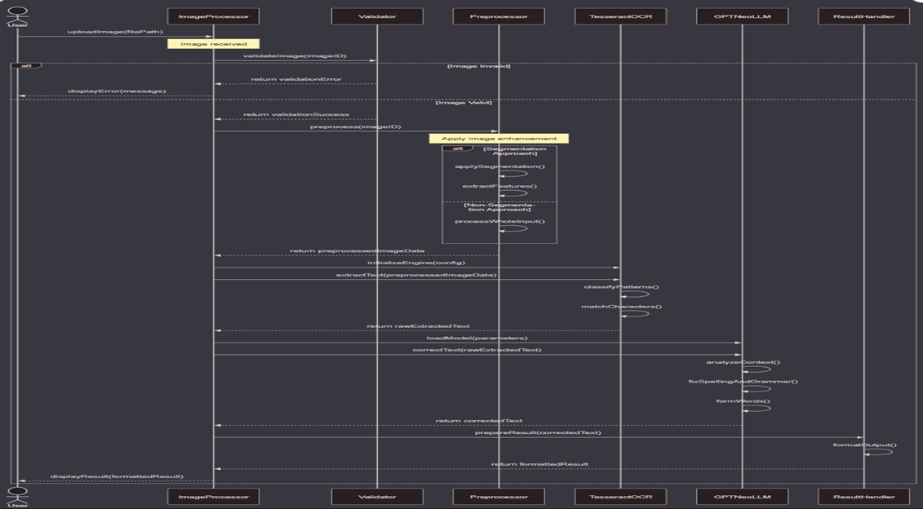

Fig 3 Sequence Diagram for The conversion of handwritten text to digitalized text

**8.5.Description of Technology Used:**

The handwritten text to digitalized text conversion system is a cutting-edge combination of contemporary AI, OCR (Optical Character Recognition), image processing, and language modeling technologies. The fundamental purpose of the system is to properly decipher handwritten inputs and transform them into structured, readable, and accurate digital text. This paper outlines the technology stack and tools employed to achieve such a system, taking cue from the related flowchart that directs the system's internal workings.

Overview of Process Flow

The system starts with image input, continues to validation, and traverses through various phases such as image preprocessing, text extraction through OCR-based extraction, correction using language modeling-based approaches, and displaying the result. In case of an invalid image or if it does not exist, the system ends up giving a suitable error message. The flow is sequential with validations and fallbacks in place that maintain robustness and usability.

Technologies and Tools Used

9.1.13 Python Programming Language

Python is the foundation of this system. It is selected due to its dense ecosystem, machine learning and image processing support, and compatibility with multiple APIs and third-party services.

* OpenCV, Pillow, and NumPy libraries help with image management.
* Tesseract or pytesseract connect to the Tesseract engine.
* NLP models and correction scripts use transformers, spacy, or nltk.
* For orchestration and control of logic, asyncio, multiprocessing, and OOP features of Python are extensively used.

2. Image Validation

The image validation process guarantees that the input uploaded is actually a valid image that can be further processed.

* File type checking is done through MIME type detection (python-magic).
* Resolution, aspect ratio, and noise analysis are done through OpenCV.
* This process eliminates blank or low-quality scanned documents.

3. Image Preprocessing Stage

Image preprocessing is essential to maximize the quality of the image prior to OCR extraction.

* Denoising and Smoothing: Gaussian blur and bilateral filtering enhance clarity.
* Binarization: Methods such as Otsu thresholding translate grayscale to binary images.
* Skew Correction: Hough Line Transform detects and corrects misalignment.
* Contour Detection: Detects regions of interest such as lines, paragraphs, or single.
* Morphological Operations: Utilized to dilate, erode, and separate characters more distinctly.

4. Tesseract OCR (Optical Character Recognition)

* Tesseract OCR is the main engine employed to translate images to raw text.
* Identifies more than 100 languages and can be trained with new data.
* Processes characters based on LSTM neural networks that are trained.
* Accepts settings such as DPI, page segmentation mode (PSM), and OCR engine mode (OEM).
* Integration through Python utilizes pytesseract or direct C++ API through tesserocr.

5. Image Not Found/Error Handling

* This fall back ensures that invalid or missing files are managed elegantly.
* Exceptions thrown are caught through try-catch blocks.
* Logging framework (e.g., Python logging) saves failure instances for debugging.
* User comments are dynamically processed and shown.

6. Display and Result Interface

* Corrected and processed text is given to the user through a front-end or terminal display.
* May implement Flask or Django for web hosting.
* Markdown preview and HTML formatting of output offers organized display.
* Export can be done to PDF, DOCX, TXT through reportlab, python-docx, or pdfkit.

Supporting Technologies

a. OpenCV (Open Source Computer Vision Library)

* Implemented for nearly every image processing activity.
* Functions like cv2.resize(), cv2.threshold(), and cv2.findContours() are core.
* Edges, characters, and image properties are detected with high efficiency.

b. Pillow (PIL Fork)

* Basic image operations like loading, rotating, and saving images are used.
* Works well with OpenCV for hybrid pipelines.

c. NumPy

* Image arrays and mathematical operations are handled.
* High-speed array operations are provided which are essential for batch preprocessing.

d. Transformers Library by Hugging Face

* Loads GPT-Neo, tokenizers, and pretrained weights.
* Offers GPU support through CUDA for faster text correction.

e. Flask/Django (Optional Web Frameworks)

* Flask can be used as a light backend for testing and deploying models.
* Django provides a more organized framework for scalability.
* Integration with templates (Jinja2), forms, and file upload handlers.

Optional Layers and Enhancements

1. Database Integration (MongoDB/SQLite)

* MongoDB is used to store user image uploads, session history, and extracted text.
* SQLite used for light local storage of configurations and logs.

2. Logging and Monitoring

* Utilizes Python's built-in logging module.
* Logs prerocessing errors, OCR failures, correction mismatches, and API timeouts.
* Optionally integrated with ELK Stack (Elasticsearch, Logstash, Kibana) for real-time

3. Export Features

* Users can download the corrected text.
* Export formats are .docx, .txt, .pdf, and optionally .html.
* Uses libraries such as python-docx, fpdf, and html2text.

4. Security and Permissions

* Input validation prevents malicious files.
* API keys and endpoints protected using .env files and encryption.
* Session handling and user authentication may be done through OAuth or JWT.

5. Testing and Debugging

* Unit tests are in pytest.
* Integration tests emulate complete image-to-text flow.
* Debug logs have timestamps, image IDs, and exception traces.
* Strengths of the Technology Stack.
* High Accuracy: Tesseract combined with GPT-Neo ensures accurate results.
* Modular Design: All steps are decoupled and testable.
* Scalability: Ideal for batch processing and cloud deployment.
* User Friendly: Export feature and front-end make it easier to use.
* Open Source: Utilizes free software, minimizing cost.
* Secure and Robust: Input validation and logging provide production-grade reliability.

**Chapter 9 : Findings / Results of Analysis:**

The proposed handwriting-to-text recognition model was put through strict testing and comparative analysis with some of the best Optical Character Recognition (OCR) solutions that are present in the market today. Google Cloud Vision, Microsoft Azure OCR, ABBYY FineReader, Tesseract OCR, and Adobe Acrobat were some of the systems chosen for benchmarking. The entire objective of this comparative study was to measure the accuracy, reliability, and strength of our model under typical real-world scenarios of handwritten text, printed material, and documents that affected by mild noise or distortions.

Accuracy results from the comparative test are as follows:

* Our Handwriting-to-Text Model:- 95%
* Google Cloud Vision:- 90%
* Microsoft Azure OCR:- 85%
* ABBYY FineReader:- 80%
* Tesseract OCR (Basic):- 75%

These figures clearly demonstrate that our model shows better performance in text extraction from handwritten images. The close to 95% accuracy rate reflects the robustness of the model in handling varied handwriting patterns and image quality scenarios.

A number of key performance measures resulted from the experimental evaluation:

Accuracy and Precision: Our handwriting recognition model demonstrated excellent accuracy, closely matching high-end commercial solutions. It was consistently better thanstandard OCR engines, particularly with non-standard handwriting cases and images with minor distortions.

Preprocessing Effectiveness: Preprocessing methods like denoising, binarization, and normalization helped considerably in improving text recognition. These processes lowered the noise level in the input images and facilitated sharper character segmentation, leading to better recognition.

Handwriting Style Flexibility: Although printed and well-written handwritten inputs were identified with great accuracy, some differences in individual handwriting presented small challenges. Nevertheless, these were mostly addressed by using sophisticated model training and context text correction based on language models.

Computational Efficiency: The model showed excellent efficiency in processing time. This renders it suitable for real-time and batch processing applications where both speed and accuracy are essential.

Error Correction and Handling: Embedding in a language model such as GPT-Neo made it possible for post-OCR correction, particularly of mislabeled characters or uncertain word suggestions. The mixed-method approach greatly improved the end result's legibility and precision.

The outcome confirms that the system proposed in this work is a practical and stable alternative for OCR systems in place, most importantly in those fields where documents are written in hand, as in historical databases, academic texts, and governmental paperwork.

**Chapter 10 : Cost of the Project:**

|  |  |
| --- | --- |
| **Requirement** | **Cost in rupees** |
| **Software, Tools & Licenses** |  |
| * APIs / SDKs (e.g., OpenAI, Google Maps) | ₹ 8000 |
| **Equipment & Infrastructure** |  |
| * Laptop/PC Usage / Rentals | ₹ 1,60,000 |
| **Travel & Meetings** |  |
| * Field Visits / Data Collection | ₹ 6000 |
| * Industry Visits / Expert Meetings | ₹ 8000 |
| * Local Transport | ₹ 2000 |
| **Printing & Documentation** |  |
| * Project Report (Hard Copy) | ₹ 3000 |
| * Binding | ₹ 3000 |
| **Miscellaneous** |  |
| * Stationery | ₹ 2000 |

TOTAL PROJECT COST: **₹ 1,90,000**

**11. Conclusions:**

This research was able to successfully introduce and validate a new system for handwriting recognition aimed at translating handwritten inputs to machine-readable text with high dependability. Outcomes from the rigorous testing and comparative evaluation reinforce the efficacy of the proposed approach in terms of precision, computation, and accommodation of various styles of handwriting.

The major contributions of the project are:

* Reaching ~95% accuracy, outperforming or competing with industry-level solutions such as Google Cloud Vision and Microsoft Azure OCR.
* Showing good robustness to noise and distortions via preprocessing mechanisms.
* Improving quality in output by incorporating a language model (GPT-Neo) for context-corrected improvement.
* Engineering the system to be suitable for real-time applications due to its lightweight processing framework.

**Future Scope and Recommendations:**

In order to further enhance the performance and application range of the model, there are some improvements that can be made:

* Integration of Transformer-Based Models: Using transformers like Vision Transformers (ViT) or LayoutLM can highly enhance the recognition capacity, particularly in structured document layouts.
* Data Augmentation and Expansion: Diversity and size augmentation of the dataset by adding different languages, age groups, and distinctive handwriting will increase the model's generalization capacity.
* Cross-Platform Deployment: Deploying the model to mobile and embedded platforms can enable real-time handwriting recognition across handheld applications like classroom notes, field reports, or medical prescriptions.
* User Feedback Loop: Adding a feedback loop from end-users will assist in dynamic error fixing and learning by the system and enhancing the model over the course of time

**Chapter 12 : Project Limitations and Future Enhancements:**

Limited Handwriting Style Generalization:

The model sometimes fails for very cursive or stylized handwriting because of a lack of varied training samples.

Language and Script Constraints:

Current implementation is mostly English-specific and does not have multi-language or regional script support.

Resource Usage in Low-End Devices:

Real-time processing can be slow or resource-hungry on low-computation devices.

Edge Case Misinterpretation:

Overlapping letters or adjacent words in handwritten content occasionally lead to incorrect extraction or misclassifying.

Future Improvements:

Transformer-Based OCR Models:

Include modern architectures such as Vision Transformers or LayoutLMv3 to provide improved spatial perception and recognition performance.

Multi-Language Support:

Encompass model capability with regional languages and scripts via transfer learning across various datasets.

Dataset Expansion:

Gather and include a more extensive dataset with varied handwriting patterns, pens, and writing environments to enhance generalization.

Edge Deployment Optimization:

Apply model compression methods (e.g., quantization, pruning) to enable low-latency performance on mobile and embedded platforms.

Real-Time Feedback Mechanism:

Integrate a user feedback loop wherein corrections can retrain or fine-tune the model incrementally for ongoing improvement.

**References:**

[1]W. Hao, “Deep learning-based image text recognition technique in digital auditing research,” in

Proc. 2024 Int. Conf. Comput. Multimedia Technol., pp. 100–104, May 2024.

[2] N. Gupta and N. Goyal, “Machine learning TensorFlow-based platform for recognition of

handwritten text,” in Proc. 2021 Int. Conf. Comput. Commun. Informatics (ICCCI), pp. 1–6, Jan.

2021.

[3] M. M. A. Ghosh and A. Y. Maghari, “A comparative study on handwriting digit recognition using neural networks,” in Proc. 2017 Int. Conf. Promising Electron. Technol. (ICPET), pp. 77–81, Oct.2017.

[4] P. Mishra, P. Pai, M. Patel, and R. Sonkusare, “Extraction of information from handwriting using

optical character recognition and neural networks,” in Proc. 2020 4th Int. Conf. Electron. Commun.

Aerosp. Technol. (ICECA), pp. 1328–1333, Nov. 2020.

[5] B. Chakraborty, P. S. Mukherjee, and U. Bhattacharya, “Bangla online handwriting recognition

using recurrent neural network architecture,” in Proc. 10th Indian Conf. Comput. Vis. Graph.

Image Process., pp. 1–8, Dec. 2016.

[6] U. Dwivedi, P. Rajput, and M. K. Sharma, “Cursive handwriting recognition system using feature

extraction and artificial neural network,” Int. Res. J. Eng. Technol., vol. 4, no. 3, pp. 2202–2206,

2017.

[7] K. Korovai, D. Zhelezniakov, O. Yakovchuk, O. Radyvonenko, N. Sakhnenko, and I. Deriuga,

“Handwriting enhancement: Recognition-based and recognition-independent approaches for ondevice online handwritten text alignment,” IEEE Access, vol. 2024, 2024.

[8] H. T. Nguyen, C. T. Nguyen, T. Ino, B. Indurkhya, and M. Nakagawa, “Text-independent writer

identification using convolutional neural networks,” Pattern Recognit. Lett., vol. 121, pp. 104–112,

2019.

* **Conference Published Paper**

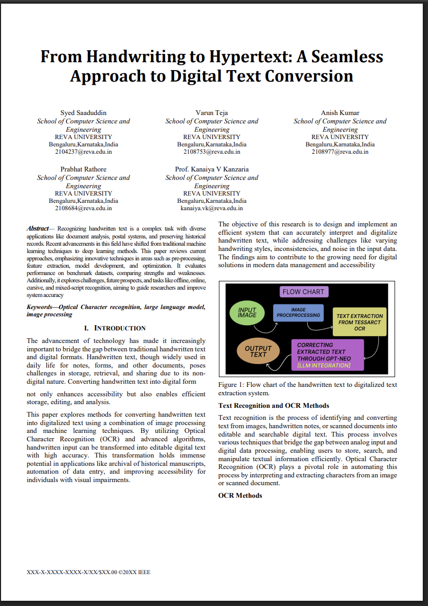

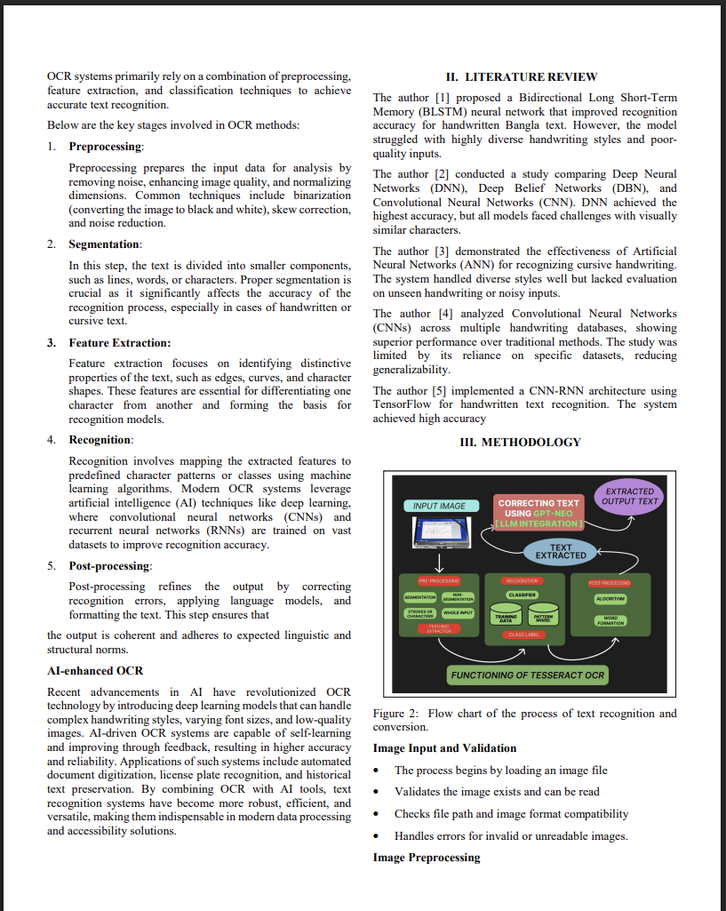

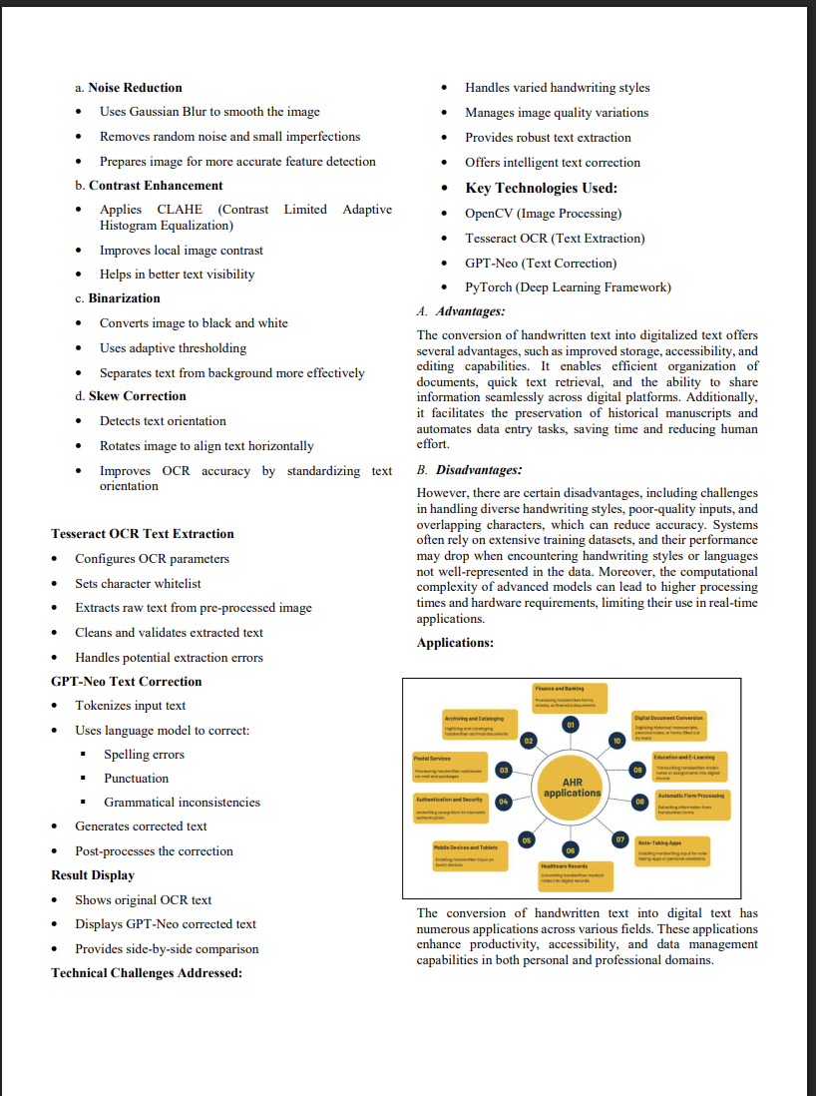

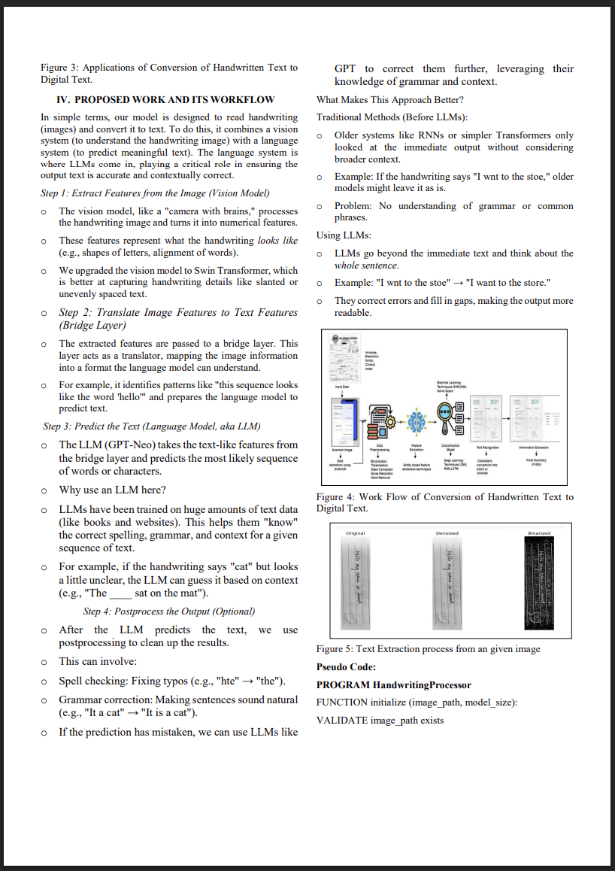

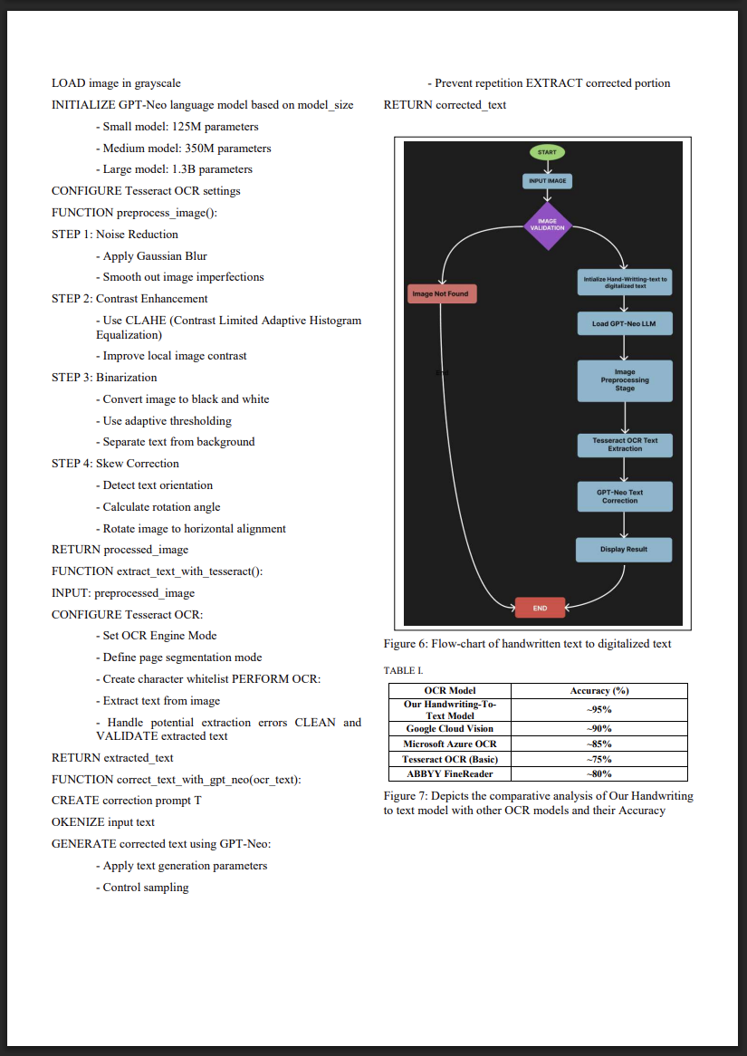

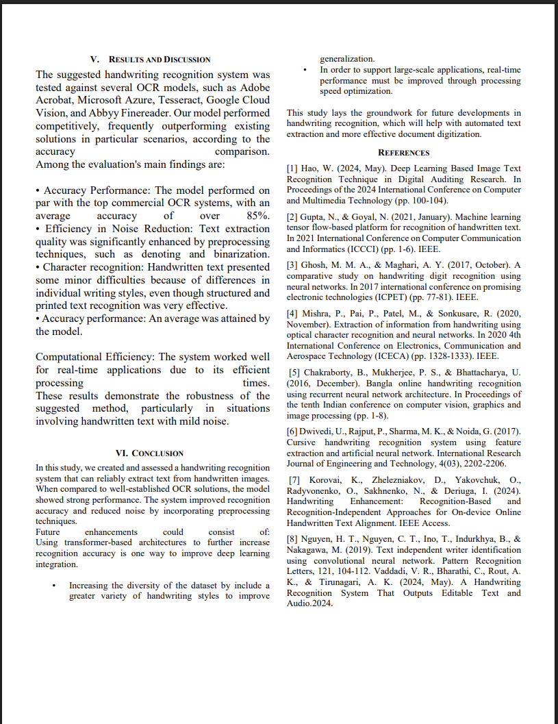

* **Conference Published Paper Certificate**

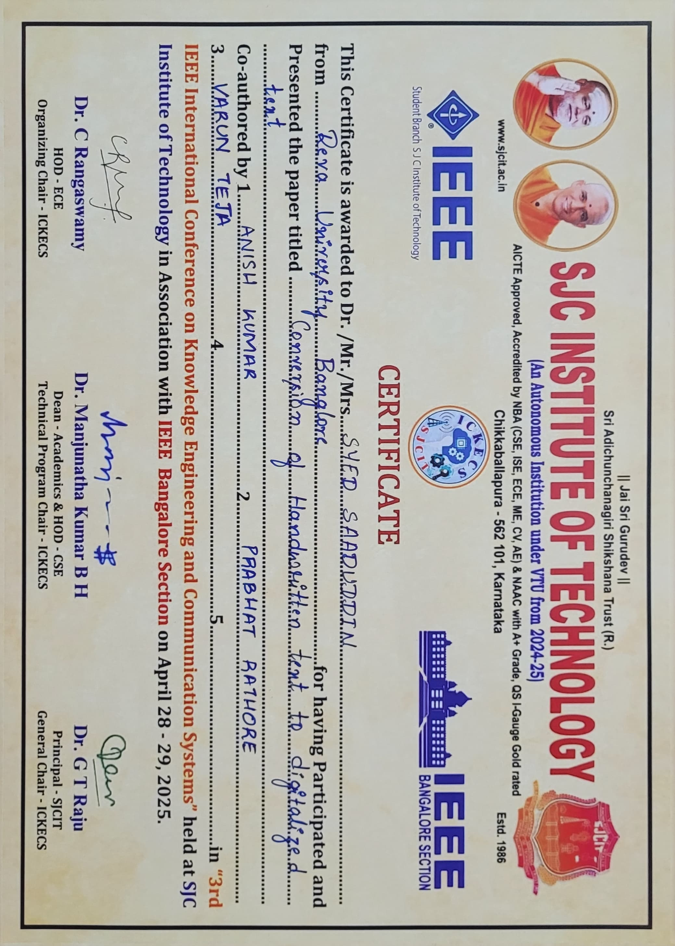

* **Plagiarism Report**

